Teacher Responsibilities | Learner Responsibilities
Communicating the amount of expected screen time | 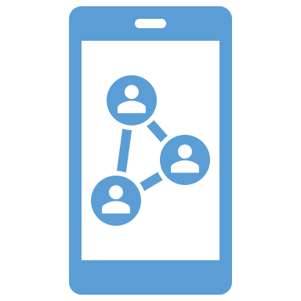  Managing both academic and personal/work-related screen time
Offering various modes and methods of the following:  - content representation,  - course participation,  - activity and assignment interaction | Taking advantage of strategies provided by teachers such as:  - scheduled breaks,  - movement opportunities,  - reading printable text,  - hand-writing assignments,  - live interaction
Streamlining the use of multiple applications especially in remote and online learning | Taking time to complete any set-up or how-to instructions/tutorials for using expected applications
- Establishing comfortable and varied workspaces  - Offering stretch opportunities | - Sitting in an upright position when using an electronic device  - Using adequate amounts of lighting and screen brightness  - Properly supporting hands/wrists, back, and legs  - Alternating workspaces  - Stretching regularly
Asking for student feedback on how to drive greater interest and engagement | Providing feedback on how to drive greater interest and engagement
Specifying roles for collaborative, digital learning | - Fulfilling the responsibilities of your group role  - Communicating issues with roles or group members to teacher
Watching for signs of digital fatigue:
- reduction in “normal” digital participation or engagement,
- minimal and/or generic responses in digital assignments,
- decreases in digital, collaborative learning efforts
- spikes in digital content-related questions due to the lack of reading digital content,
- increased complaints about workload or expressed confusion over assignments
- reduction in virtual class attendance,
- increases in late digital assignment submissions,
- very delayed or no student responses to emails,
- rise in physical, emotional, or mental symptoms: eyestrain, ear tenderness, headaches, boredom, stress, anxiety, exhaustion, and/or depression.

