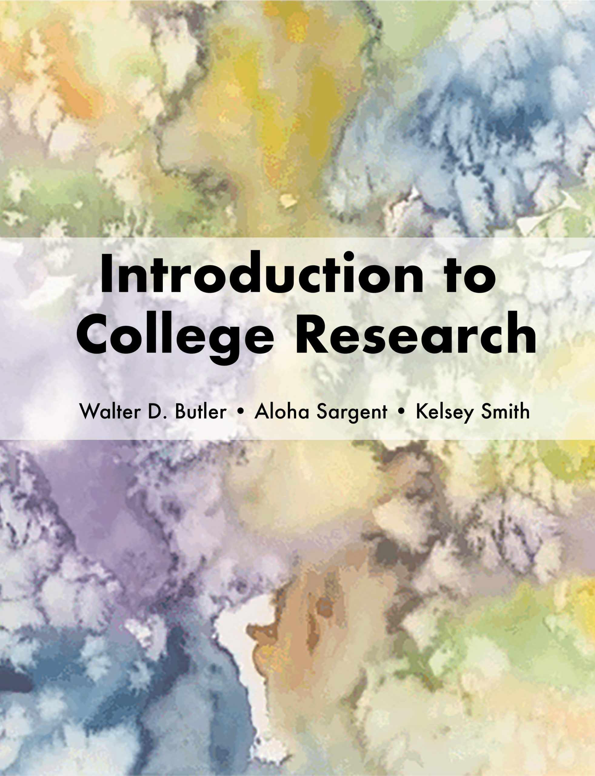

Introduction to College Research

Introduction to College Research

Walter D. Butler, Aloha Sargent, and Kelsey Smith

Cynthia Orozco and Xiao Behlendorf

Introduction to College Research by Walter D. Butler, Aloha Sargent, and Kelsey Smith is licensed under a Creative Commons Attribution 4.0 International License, except where otherwise noted.

Contents
- Title Page
- A Note for Instructors
- Introduction
- College Research and Information Literacy
- What This Book Will Cover
- The Age of Algorithms
- What are Algorithms?
- The Influence of Algorithms
- Algorithmic Bias
- The Attention Economy
- Algorithms and Polarization
- Filter Bubbles
- Conclusion
- Disinformation
- Information Disorder, Truth, and Trust
- Web Evaluation Skills: A “Bleak” Track Record
- Information Cynicism
- College Students and Cynicism
- Information Hygiene and Info-Environmentalism
- Conclusion
- Fact-Checking
- Why Fact-Checking?
- The SIFT Method
- Using Wikipedia Effectively
- Fact-Checking Images and Memes
- Conclusion
- Types of Information Sources
- Chapter Scenario
- Information Sources: Primary, Secondary, Tertiary
- Critical Thinking
- Information Sources: Traditional Formats
- Information Sources: Media
- Information Sources: Online
- Critical Thinking
- Information Sources: Bias
- Critical Thinking
- Conclusion
- Getting Your Research Started
- Choosing a Topic
- Background Reading
- Conclusion
- Search Strategies
- Research Questions
- Identifying the Main Concepts
- Avoiding Confirmation Bias
- Brainstorming Related Terms
- Creating a Search Statement
- Conclusion
- Finding Materials in the Library
- Chapter Scenario
- Using OneSearch: Your California Community College Library’s Search Tool
- Critical Thinking
- Finding Your Books
- Filters and Advanced Search Options in OneSearch
- Practice
- How Libraries Organize Materials
- Dewey Decimal Classification (DDC)
- Critical Thinking
- Library of Congress Classification (LCC)
- Practice
- Critical Thinking
- Conclusion
- Using Library Databases
- Chapter Scenario
- Library Databases: What’s Inside Them?
- Critical Thinking
- Choosing a Library Database
- Critical Thinking
- Specialized Library Databases: Videos, Ebooks, and More!
- Scholarly Articles, Magazine Articles, and Newspaper Articles
- You Found Some Resources! Now What?
- Preparing to Use a Database: What Do You Need to Find?
- Full Text? HTML, PDF, and EPUB
- Critical Thinking
- Conclusion
- Searching the Web: Strategies and Considerations
- Chapter Scenario
- A Very Brief History of the Internet
- Critical Thinking
- Search Engines and Tools
- Comparing Search Tools
- Practice
- Academic Search Tools
- Open Access
- Critical Thinking
- Searching and Privacy
- Controlling Your Search
- Practice
- Citing: Websites, Web pages, Files, Articles
- Conclusion
- Ethical and Legal Use of Information
- Contributing to the Conversation
- Why We Cite Sources
- Plagiarism and Academic Integrity
- Conclusion
- Citing Sources
- Citation Styles
- When to Cite Sources
- MLA Style
- APA Style
- Citation Steps for Any Style
- Citation Generators
- Conclusion
- Glossary

Title Page

Introduction to College Research

Authors
Walter D. Butler (Pasadena City College)
Aloha Sargent (Cabrillo College)
Kelsey Smith (West Hills College Lemoore)

Editor
Cynthia M. Cohen (Los Angeles Valley College)

Contributors
Cynthia Mari Orozco (East Los Angeles College)
Xiaoyang Behlendorf (Los Angeles Valley College)

Version
Current Version Published March 2021

Book Cover Art
Cheryl R. Niesen

Special Thanks
This textbook was made possible by the generous support of the ASCCC OERI.

Introduction to College Research by Walter D. Butler, Aloha Sargent, and Kelsey Smith is licensed under a Creative Commons Attribution 4.0 International License, except where otherwise noted.

A Note for Instructors

Open License
This is an OER textbook with a Creative Commons Attribution license, except where otherwise noted (the “Sources” section at the bottom of each page has specific attributions and citations for external sources). You are free to retain, reuse, revise, remix, and redistribute this textbook, as long as attributions are included. A suggested attribution is provided at the bottom of every page of this book.

Supplementary Canvas Resources Available
This textbook has supplementary Canvas modules available for import/download in the Canvas Commons (if the link doesn’t work, search for the title of the textbook or search for ASCCC OERI).

Additional Formats Available
In addition to Pressbooks, this book can be downloaded in a variety of formats. There is also a printed and bound copy of this textbook available to order through LuLu.com.

Accessibility
The textbook and supplementary Canvas modules were designed to be fully accessible, and have also been reviewed by an ASCCC OERI accessibility reviewer.

Let Us Know If You Are Using This Textbook!
Thank you in advance for sharing your interest in adopting all or part of Introduction to College Research. By completing this brief form, we will be able to better measure impact, usage, and the importance of information literacy instruction:
Adoption Form: Introduction to College Research

Let Us Know If You Have a Suggested Edit or Revision!
Help us improve this resource by reporting errors or suggesting edits or revisions:
Suggestion Form: Introduction to College Research

PART I

Introduction

Learning Objectives
By the end of this chapter, you will be able to:
- Define information literacy

Chapter 1

College Research and Information Literacy


Why This Book?
The key to success in college research is to develop and hone your information literacy skills. These skills will prepare you to find and use information not only for college, but also in the workplace and your personal life. Having strong information literacy skills will make you a more thoughtful and effective consumer and creator of information, and will increase your awareness of and resilience toward the psychological, physiological, and sociological effects of living in a society overloaded with information.

“Recent events underscore the threat that digital illiteracy poses to public health and democracy” (Breakstone et al.).

What is Information Literacy?
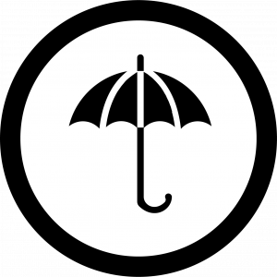
Some of the skills and abilities that fall under the umbrella of information literacy include:
- research skills
- critical thinking
- media literacy
- digital literacy
- news literacy
- algorithmic literacy
- ethical reasoning
- civic engagement
Information literacy acknowledges that students are not just passive consumers of knowledge, but that you are active creators and participants in the information environment. It is a set of skills that aims to help students navigate this landscape, “not just for college courses but beyond—in the workplace, in their personal lives, as lifelong learners, and as news consumers, creators, and voters” (Head et al. 12; emphasis added).
You might also hear this idea referred to as “information competency,” which is an equivalent term.

“Information literacy is an integrated set of skills, knowledge, practices, and dispositions that prepares students to discover, interpret, and create information ethically while gaining a critical understanding of how information systems interact to produce and circulate news, information, and knowledge” (Head et al. 8).

National & International Perspectives
In the U.S., the Obama administration made information literacy a priority. The 2009 “Presidential Proclamation on National Information Literacy Awareness Month” stated that:
Over the past decade, we have seen a crisis of authenticity emerge. We now live in a world where anyone can publish an opinion or perspective, whether true or not, and have that opinion amplified within the information marketplace. At the same time, Americans have unprecedented access to the diverse and independent sources of information, as well as institutions such as libraries and universities, that can help separate truth from fiction and signal from noise….The ability to seek, find, and decipher information can be applied to countless life decisions, whether financial, medical, educational, or technical.
Internationally, the Alexandria Proclamation of 2005 defined the term as a human rights issue: “Information Literacy lies at the core of lifelong learning. It empowers people in all walks of life to seek, evaluate, use and create information effectively to achieve their personal, social, occupational and educational goals. It is a basic human right in a digital world and promotes social inclusion in all nations.”
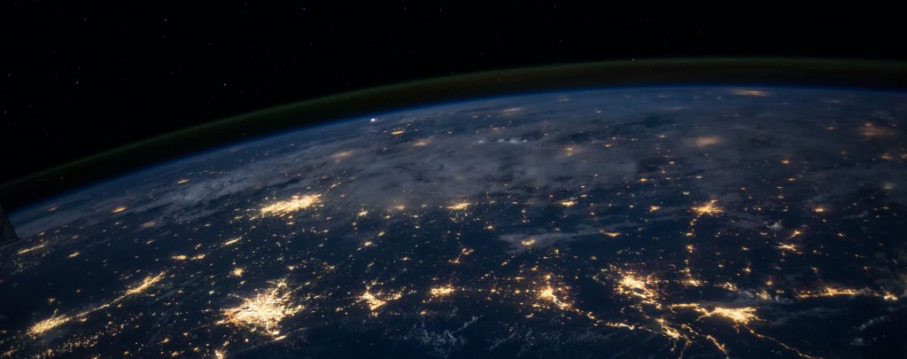

“Information literacy is the set of integrated abilities encompassing the reflective discovery of information, the understanding of how information is produced and valued, and the use of information in creating new knowledge and participating ethically in communities of learning” (“Framework for Information Literacy for Higher Education”).

Sources
“Beacons of the Information Society: The Alexandria Proclamation on Information Literacy and Lifelong Learning.” IFLA, 26 Jan. 2015.
Breakstone, Joel, et al. “Lateral Reading: College Students Learn to Critically Evaluate Internet Sources in an Online Course.” Harvard Kennedy School Misinformation Review, vol. 2, no. 1, 2021, doi.org/10.37016/mr-2020-56. Licensed under CC BY 4.0
“Framework for Information Literacy for Higher Education” by the Association of College & Research Libraries is licensed under CC BY-NC-SA 4.0
Head, Alison J., Barbara Fister, and Margy MacMillan. “Information Literacy in the Age of Algorithms.” Project Information Literacy, 15 Jan. 2020. Licensed under CC BY-NC-SA 4.0
Image: “Digital Silhouette” by Su San Lee is in the Public Domain, CC0
Image: “Earth from Space” by NASA is in the Public Domain, CC0
Image: “Umbrella” by Vectors Market, adapted by Aloha Sargent, is licensed under CC BY 4.0
“Presidential Proclamation: National Information Literacy Awareness Month” by Barack Obama is in the Public Domain.

Chapter 2

What This Book Will Cover


Overview
This book acknowledges our changing information landscape, covering key concepts in information literacy to support a research process with intention. We start by critically examining the online environment many of us already engage with every day, looking at algorithms, the attention economy, information disorder and cynicism, information hygiene, and fact-checking. We then move into an exploration of information source types, meaningful research topics, keyword choices, effective search strategies, library resources, Web search considerations, the ethical use of information, and citation.

Key Questions
Throughout the book, we will explore a number of critical and timely questions, including:
- Are Google search results really an unbiased presentation of the best available information on a research question?
- How do algorithms and “engagement” on digital platforms influence the way that we perceive information, and each other?
- In a world of misinformation and disinformation, how do we determine truth? How do we know which sources of information to trust?
- When we find a source of information, how can we verify that it is a reliable and effective piece of evidence for our research?
- Why might it be valuable to include different information types and formats in our research? How do we recognize when a resource has bias? Whose voices are included in our research, and whose are left out?
- Why is choosing a topic so often the hardest part of the research process? What are some strategies for developing a meaningful research topic?
- How do we break a research topic into an effective combination of keywords and phrases for searching? How can we avoid confirmation bias when choosing our keywords?
- How do we search and find information through our college library? How are the materials organized in the library?
- What are library “databases” and how are they different from Google? What kinds of information can be found in these databases, and what are the advantages of using them?
- How has Web search become embedded in our daily lives, and what conveniences and concerns does this present? How can we conduct academic research effectively on the Web?
- When we engage in the scholarly conversation through research, how can we respect intellectual property and academic integrity by using sources ethically?
- How can we give credit to the work of others by citing our sources in MLA, APA, or another style?
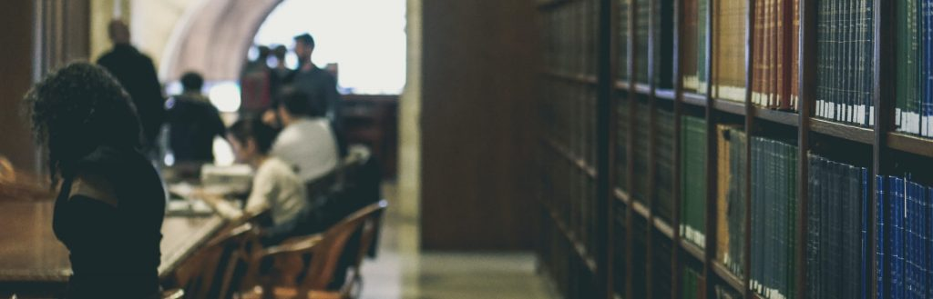

Sources
Image: “Open Wide Book” by ASTERISK KWON is in the Public Domain, CC0
Image: “Selective Focus: New York Public Library” by Davide Cantelli is in the Public Domain, CC0

PART II

The Age of Algorithms

Learning Objectives
By the end of this chapter, you will be able to:
- Describe algorithms and their pervasiveness
- Identify key concerns surrounding algorithmic bias
- Recognize the psychological, physiological, and sociological effects of algorithms, the attention economy, and digital polarization

Chapter 3

What are Algorithms?

Overview

“Everyone who has accessed the internet has experienced the personalizing actions of algorithms, whether they realize it or not. These invisible lines of code can track our interactions, trying to game our consumer habits and political leanings to determine what ads, news stories and information we see….As tracking practices have become more common and advanced, it has become urgent to understand how these computer programs work and have widespread impact. How do students understand the hidden filters that influence what they see and learn, and shape what they think and who they are?” (Head et al. 13)
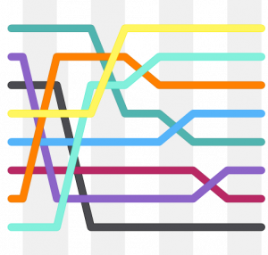
Algorithms are step-by-step instructions that computers follow to complete tasks, solve problems, and make automated decisions. They use data to make predictions about people, including their preferences, attributes, and behaviors. Algorithms power nearly everything we see online, including search engines, social media, video games, online dating, and smartphone apps. They are used to shape and filter content on the platforms many of us interact with daily, such as Google, YouTube, Instagram, Netflix, Facebook, Amazon, Twitter, and Spotify. For example, algorithms determine which websites you see first in your Google search results, which posts you see on Facebook, and which videos YouTube “recommends” and autoplays for you.

Data & Algorithms
The following TED Talk [9:44] with computer scientist Jennifer Golbeck provides a clear explanation of how data is collected on social media sites, and how this can be used to create algorithms that predict attributes like political affiliation, intelligence, sexual orientation, relationship strength, and even drug/alcohol usage.
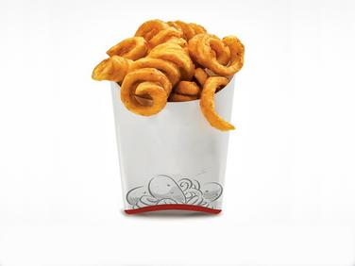
A TED element has been excluded from this version of the text. You can view it online here: https://oer.pressbooks.pub/collegeresearch/?p=35
Note: Turn on closed captions with the subtitles button or use the interactive text transcript if you prefer to read.

Sources
Head, Alison J., Barbara Fister, and Margy MacMillan. “Information Literacy in the Age of Algorithms.” Project Information Literacy, 15 Jan. 2020. Licensed under CC BY-NC-SA 4.0
Image: “Shell Sorting Algorithm Color Bars” by Balu Ertl is licensed under CC BY 4.0
“Your Social Media ‘Likes” Expose More Than You Think: Jennifer Golbeck” by TED is licensed under CC BY-NC-ND 4.0

Chapter 4

The Influence of Algorithms


“We live in an era of ambient information. Amidst the daily flood of digital news, memes, opinion, advertising, and propaganda, there is rising concern about how popular platforms, and the algorithms they increasingly employ, may influence our lives, deepen divisions in society, and foment polarization, extremism, and distrust” (Head et al. 1).

Positive & Negative
As companies, governments, and other organizations continue to collect and analyze massive amounts of our data, the use of algorithms has become pervasive. In fact, many are referring to this period as the “Age of Algorithms” or the “Algorithm Era,” and researchers are considering the significant impacts that these tools may have—both positive and negative.
There is no doubt that algorithms can be useful and help to improve our lives. For example, it certainly saves a lot of time and frustration to be able to pull up a map on our phones and instantly determine the fastest way to reach our destination. However, as technology and social media scholar danah boyd has noted, “the same technology can be used to empower people…or harm them. It all depends on who is using the information to what ends” (qtd. in Rainie and Anderson). Eni Mustafaraj, Assistant Professor of Computer Science at Wellesley College, similarly notes that “if we want more people in the world to have access to the total human knowledge accessible on the Internet, we need algorithms. However, what we need to object against are the values driving the companies that own these algorithms” (qtd. in Head et al. 42).

Concerns
What happens when algorithms are used to predict when college students are “cheating” on a test, or to predict who should be hired for a job or who should get a loan, or to decide the type of information we see in our social media newsfeeds, or to calculate credit scores, or even to predict criminal behavior and determine prison sentences? Are Google search results really an unbiased presentation of the best available information on a research question? How do algorithms impact our perception of a research topic, or of our own realities?
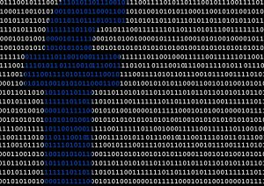
One of the most prominent examples in recent history is the Facebook-Cambridge Analytica data scandal, in which the personal profile data of at least 87 million Facebook users was harvested by a political consulting firm working for the Trump campaign. In this case, Cambridge Analytica used algorithms to develop psychographic profiles in order to more effectively direct its messaging and influence voter behavior in the 2016 U.S. Presidential election.

Zoom in or read the text version of the infographic

Sources
Head, Alison J., Barbara Fister, and Margy MacMillan. “Information Literacy in the Age of Algorithms.” Project Information Literacy, 15 Jan. 2020. Licensed under CC BY-NC-SA 4.0
Image: “Big Data is Watching You” by ev is in the Public Domain, CC0
Image: “Facebook Concept Binary” by geralt on Pixabay
Infographic: “Life in the Age of Algorithms” by Jessica Yurkofsky for Project Information Literacy is licensed under CC BY-NC-SA 4.0
Rainie, Lee, and Janna Anderson. “Code Dependent: Pros and Cons of the Algorithm Age.” Pew Research Center, 8 Feb. 2017.

Chapter 5

Algorithmic Bias

“Although the impulse is to believe in the objectivity of the machine, we need to remember that algorithms were built by people” (Chmielinski, qtd. in Head et al. 38).

Overview & Examples
Because we often assume that algorithms are neutral and objective, they can inaccurately project greater authority than human expertise. Thus, the pervasiveness of algorithms—and their incredible potential to influence our society, politics, institutions, and behavior—has been a source of growing concern.
Algorithmic bias is one of those key concerns. This occurs when algorithms reflect the implicit values of the humans involved in their creation or use, systematically “replicating or even amplifying human biases, particularly those affecting protected groups” (Lee et al.). In search engines, for example, algorithmic bias can create search results that reflect racist, sexist, or other social biases, despite the presumed neutrality of the data. Here are just a few examples of algorithmic bias (Lee et al.):
- An algorithm used by judges to predict whether defendants should be imprisoned or released on bail, was found to be biased against African-Americans.
- Amazon had to discontinue using a recruiting algorithm after discovering gender bias: The algorithm was penalizing any resume that contained the word “women’s” in the text, because the data was based on resumes historically submitted to Amazon, which were predominantly from white males.
- Princeton University researchers analyzed algorithms and found that they picked up on existing racial and gender biases: European names were perceived as more pleasant than those of African-Americans, and the words “woman” and “girl” were more likely to be associated with the arts instead of science and math.
- Numerous articles have examined the role that YouTube’s recommendation algorithm might play in radicalizing viewers.

Challenging the Algorithms of Oppression
Dr. Safiya U. Noble, Associate Professor at UCLA (Departments of Information Studies and African American Studies) is the author of the book, Algorithms of Oppression: How Search Engines Reinforce Racism. She is also Co-Director of the UCLA Center for Critical Internet Inquiry, and co-founder of the Information Ethics & Equity Institute. In the video below [3:43], Dr. Noble discusses her findings about algorithmic bias in Google search results, particularly for women of color.
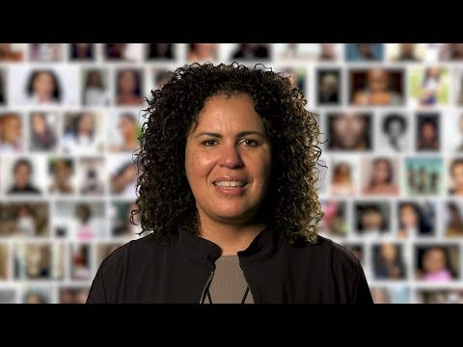
A YouTube element has been excluded from this version of the text. You can view it online here: https://oer.pressbooks.pub/collegeresearch/?p=42
Note: This video is auto-captioned. Accurate captions are available at the Amara version. Use the text transcript if you prefer to read.

Fighting Bias in Algorithms
Joy Buolamwini, MIT researcher, Rhodes Scholar, Fulbright Fellow, poet of code, and founder of the Algorithmic Justice League, found that the algorithms powering facial recognition software systems were failing to recognize darker-skinned complexions, because they were based on data sets that were largely white and male. Now she’s committed to fighting bias in machine learning, which she calls the “coded gaze.” In the following video [8:44], she explains her work with facial recognition and also asks important questions about how algorithms influence critical decisions, like: Who gets hired or fired? Do you get that loan? Do you get insurance? Are you admitted into the college you wanted to get into? Do you and I pay the same price for the same product purchased on the same platform?
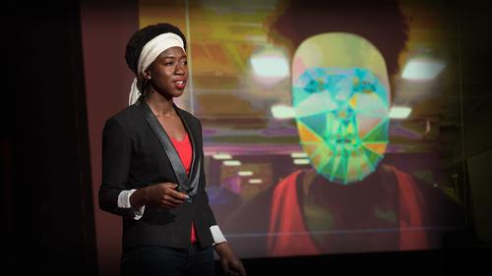
A TED element has been excluded from this version of the text. You can view it online here: https://oer.pressbooks.pub/collegeresearch/?p=42
Note: Turn on closed captions with the subtitles button or use the interactive text transcript if you prefer to read.

Weapons of Math Destruction
Cathy O’Neil has written several books on data science, including Weapons of Math Destruction. She was the former Director of the Lede Program in Data Practices at Columbia University Graduate School of Journalism. In the following video [13:11], she explains how algorithms are not fair and objective, and may in fact “automate the status quo” and “codify” sexism and bigotry. She concludes that these secret “black box” algorithms, created by private companies, can hide ugly truths, often with destructive results.
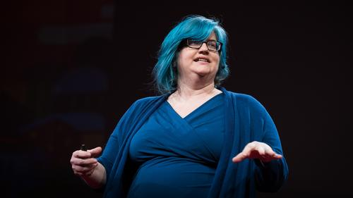
A TED element has been excluded from this version of the text. You can view it online here: https://oer.pressbooks.pub/collegeresearch/?p=42
Note: Turn on closed captions with the subtitles button or use the interactive text transcript if you prefer to read.

Sources
“Algorithms of Oppression, Faculty Focus: Safiya Umoja Noble.” YouTube, uploaded by USC Annenberg, 28 Feb. 2018.
“The Era of Blind Faith in Big Data Must End: Cathy O’Neil” by TED is licensed under CC BY-NC-ND 4.0
Head, Alison J., Barbara Fister, and Margy MacMillan. “Information Literacy in the Age of Algorithms.” Project Information Literacy, 15 Jan. 2020. Licensed under CC BY-NC-SA 4.0
“How I’m Fighting Bias in Algorithms: Joy Buolamwini” by TED is licensed under CC BY-NC-ND 4.0
Lee, Nicole Turner, Paul Resnick, and Genie Barton. “Algorithmic Bias Detection and Mitigation: Best Practices and Policies to Reduce Consumer Harms.” Brookings, 22 May 2019.
Text adapted from “Digital Citizenship” by Aloha Sargent and James Glapa-Grossklag for @ONE, licensed under CC BY 4.0

Chapter 6

The Attention Economy


“Attention is a resource—a person has only so much of it” (Crawford 11).
“How do you focus your attention? How do you protect it? How do you apply it productively and strategically, and avoid giving it to bad actors or dubious sources? And how do you do that in a world where decisions about what to engage with are made in seconds, not minutes or hours?” (Caulfield)

Overview
In a world where information is abundant, where we are overloaded and overwhelmed with information on a daily basis, attention is the scarcity (Caulfield).
Algorithms are being used by social media platforms and news organizations to keep our attention focused on their websites. These and other digital platforms have discovered that the best way to keep us engaged with their websites is to promote sensational, divisive, or outrage-inducing content. Emotional responses are what keep us clicking, liking, commenting, and sharing—when trying to capture attention, our anger, fear and disgust are a signal in the noise. “People tend to react more to inputs that land low on the brainstem. Fear and anger produce a lot more engagement and sharing than joy. The result is that the algorithms favor sensational content over substance” (McNamee).

“Engagement”

“Many of the biggest problems we face in this moment as a society result from decisions being made by the hidden creators of our digital world—the designers, developers, and editors that create and curate the media we consume….They do this by focusing on one over-simplified metric, one that supports advertising as its primary source of revenue. This metric is called engagement, and emphasizing it—above all else—has subtly and steadily changed the way we look at the news, our politics, and each other” (Rose-Stockwell, “This Is How Your Fear and Outrage Are Being Sold for Profit”).
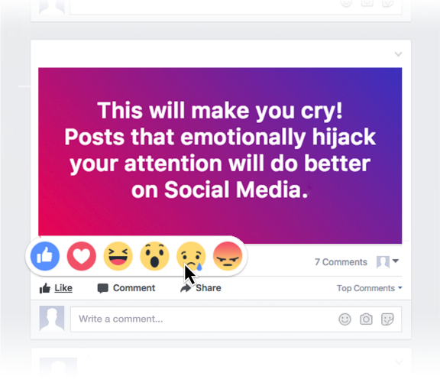
Tobias Rose-Stockwell, a writer and technologist focused on ethical design, explains how emotional reactions are strong indicators of engagement, and how divisive content that captures our attention will be shown in our feeds first. We then share our moral judgments with our own followers, creating what he calls “outrage cascades” that dominate our conversations online.
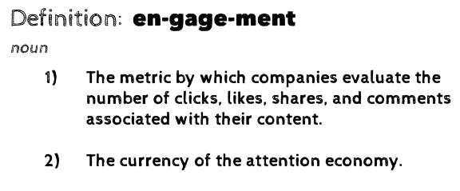
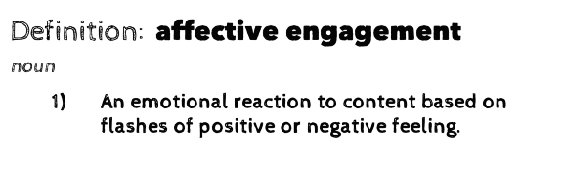
Indeed, in their report on “Information Disorder,” researchers Wardle and Derakhshan emphasize that: “Social networks are driven by the sharing of emotional content. The architecture of these sites is designed such that every time a user posts content—and it is liked, commented upon or shared further— their brain releases a tiny hit of dopamine (13).
The most notable example of this idea? Most of our content feeds and timelines are no longer sorted chronologically or by relevance. Instead, the decision about which content to show us is instead based on how likely we are to engage with it.
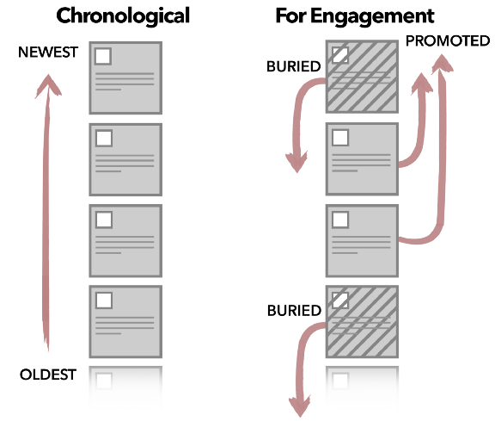
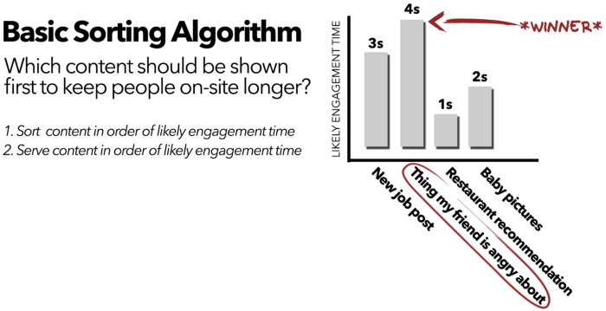

Sources
Caulfield, Mike. “Attention Is the Scarcity.” Hapgood, 4 Feb. 2019.
Crawford, Matthew. The World Beyond Your Head: On Becoming an Individual in an Age of Distraction. Farrar, Straus, and Giroux, 2016.
Graphics: “This Will Make You Cry,” “Engagement” definitions, “Chronological vs. Engagement Feed,” “Basic Sorting Algorithm” by Tobias Rose-Stockwell are licensed under CC BY-NC 4.0
Image: “Boy Mobile Phone” by Andi_Graf on Pixabay
McNamee, Roger. “How to Fix Facebook – Before It Fixes Us.” Washington Monthly, Jan/Feb/Mar. 2018.
Rose-Stockwell, Tobias. “How to Design Better Social Media.” Medium, 13 Apr. 2018. Licensed under CC BY-NC 4.0
Rose-Stockwell, Tobias. “This Is How Your Fear and Outrage Are Being Sold for Profit.” Medium, 14 July 2017. Licensed under CC BY-NC 4.0.
Wardle, Claire, and Hossein Derakhshan. “Information Disorder: Toward an Interdisciplinary Framework for Research and Policy Making.” Council of Europe, 27 Sept. 2017.

Chapter 7

Algorithms and Polarization

“At its best the net gives us voices and perspectives we would have never discovered otherwise….at its worst, our net-mediated digital world becomes an endless stream of binary actions—like/don’t like, share/pass, agree/disagree, all in an architecture that slowly segments and slips us into our correct market position a click at a time, delivering us a personalized, segregated world. We can’t laud the successes of one half of this equation without making a serious attempt to deal with the other side of the story” (Caulfield).

Polarization for Profit
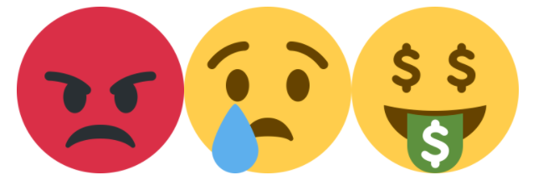
Leading scholars in this field have argued that digital platforms are using algorithms to promote polarization for profit. That is, corporations use these algorithms to engage and outrage, to knowingly cause divisiveness and polarization, ultimately for one simple purpose: to sell ads. In other words, these platforms have used “massive surveillance of our behavior, online and off, to generate increasingly accurate, automated predictions of what advertisements we are most susceptible to and what content will keep us clicking, tapping, and scrolling down a bottomless feed” (Tufekci).
For a fascinating explanation of this, watch the following TED Talk [22:47] from Zeynep Tufekci, techno-sociologist and Associate Professor at UNC School of Information and Library Science:
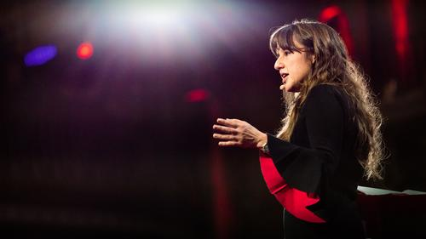
A TED element has been excluded from this version of the text. You can view it online here: https://oer.pressbooks.pub/collegeresearch/?p=53
Note: Turn on closed captions with the subtitles button or use the interactive text transcript if you prefer to read.

Sources
Caulfield, Mike. “Announcing the Digital Polarization Initiative, an Open Pedagogy Project.” Hapgood, 7 Dec. 2016.
Image: “Twemojis” by Twitter Open Source are licensed under CC BY 4.0
Tufekci, Zeynep. “It’s the (Democracy-Poisoning) Golden Age of Free Speech.” Wired, 16 Jan. 2018.
“We’re Building a Dystopia Just to Make People Click on Ads: Zeynep Tufekci” by TED is licensed under CC BY-NC-ND 4.0

Chapter 8

Filter Bubbles


The Problem With Personalization

“I’m more concerned about, like, the larger scale trend of predicting what we want, but then also predicting what we want in ways that push a lot of people towards the same cultural and political endpoint” (Anonymous student qtd. in Head et al. 20).
One significant and widely-discussed feature of the Age of Algorithms has been the “personalization” of information we see online. Algorithms will filter, sort, and personalize information in an attempt to provide content that is relevant to our interests, based on, for example, our search histories and patterns of past online activities. This type of algorithmic personalization may actually distort, manipulate, and amplify our own worldviews by creating so-called “filter bubbles” that limit our exposure to outside perspectives.

“Using algorithms to deliver content that we are most likely to enjoy, these platforms reinforce our worldviews and allow us to stay encased in our safe, comfortable echo chambers….The fundamental problem is that “filter bubbles” worsen polarization by allowing us to live in our own online echo chambers and leaving us with only opinions that validate, rather than challenge, our own ideas” (Wardle and Derakhshan 49).
Roger McNamee, an early Facebook investor-turned-critic, considers filter bubbles to be “the most important tool used by Facebook and Google to hold user attention” because they lead to an “unending stream of posts that confirm each user’s existing beliefs.” The result is polarization: “Everyone sees a different version of the internet tailored to create the illusion that everyone else agrees with them.” Further, this “continuous reinforcement of existing beliefs tends to entrench those beliefs more deeply, while also making them more extreme and resistant to contrary facts.”
For an explanation of this problem, watch Eli Pariser’s “Filter Bubbles” TED Talk [8:49], based on his influential 2011 book of the same name:
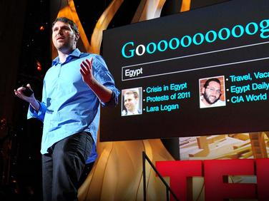
A TED element has been excluded from this version of the text. You can view it online here: https://oer.pressbooks.pub/collegeresearch/?p=57
Note: Turn on closed captions with the subtitles button or use the interactive text transcript if you prefer to read.

New Research on Filter Bubbles
A 2018 study has called the filter bubble premise into question, finding that polarization could actually increase upon exposure to opposing views (Bail et al.). Most notably, this study found that “Republicans who followed a liberal Twitter bot became substantially more conservative” (Bail et al. 9216). This suggests that exposure to opposing viewpoints (which are often presented with a divisive and moralistic tone in order to capture our attention) may actually backfire, and create further polarization by causing negative or defensive reactions.
An interesting 2017 study examined polarization in the U.S. across different age ranges and surprisingly found that “growth in polarization in recent years is largest for the demographic groups least likely to use the internet and social media”—namely, those over 75 years old (Boxell et al.; emphasis added). Indeed, in a 2020 study, students expressed concerns about the ability of older adults to navigate systems designed for algorithmic attention, with one student noting that “everyone was so focused on making sure that kids learned that they forgot they also needed to teach grandparents” (Head et al. 26).
This idea might be further understood with the results of two 2017 studies which showed that:
- Users of social media and search engines experience more diversity than non-users
- People who are involved in politics online are “more likely to double-check questionable information they find on the internet and social media, including by searching online for additional sources in ways that will pop filter bubbles” (Wardle and Derakhshan 53).


Sources
Bail, Christopher A., et al. “Exposure to Opposing Views on Social Media Can Increase Political Polarization.” PNAS, vol. 115, no. 7, 2018, pp. 9216-21, doi.org/10.1073/pnas.1804840115. Licensed under CC BY-NC-ND 4.0
“Beware Online ‘Filter Bubbles’: Eli Pariser” by TED is licensed under CC BY-NC-ND 4.0
Boxell, Levi, et al. “Is the Internet Causing Political Polarization? Evidence from Demographics.” NBER Working Paper 23258, Mar. 2017, doi:10.3386/w23258.
Head, Alison J., Barbara Fister, and Margy MacMillan. “Information Literacy in the Age of Algorithms.” Project Information Literacy, 15 Jan. 2020. Licensed under CC BY-NC-SA 4.0
Image: “Bubbles in BCN” by Marc Sendra Martorell is in the Public Domain, CC0
Image: “Water Droplets” by Nariman Mesharrafa is in the Public Domain, CC0
Wardle, Claire, and Hossein Derakhshan. “Information Disorder: Toward an Interdisciplinary Framework for Research and Policy Making.” Council of Europe, 27 Sept. 2017.

Chapter 9

Conclusion
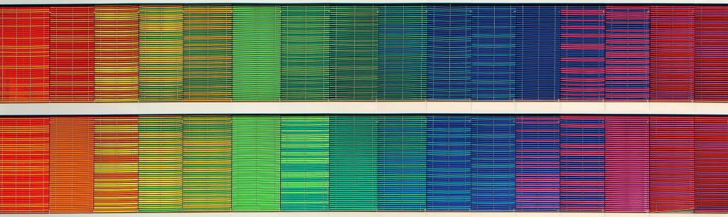
This chapter introduced the often concerning effects of living in the Age of Algorithms, including algorithmic bias, the attention economy, and digital polarization. These overlapping and intersecting concepts will greatly shape the type of information we see online, and will influence our opinions, behaviors, decisions, and worldviews.

“Despite the emerging awareness of many of the terrible side effects of these platforms, we are dependent on them. They’ve become our local news channels, our emergency communication systems, our town squares, and the primary windows into the lives of our loved ones and governments. They are a critical part of how we rally around shared causes and engage with our politics. How do we reconcile their toxicity with their utility?” (Rose-Stockwell; emphasis added)
So what can we do? We are not suggesting that you completely abandon social media and other digital platforms like Google and YouTube. Instead, our aim is to increase awareness and understanding of the information environments that we inhabit on a daily basis, so that we can take advantage of the benefits they offer and use them more effectively.

Sources
Image: “Rainbow Frequency” by Ricardo Gomez Angel is in the Public Domain, CC0
Rose-Stockwell, Tobias. “How to Design Better Social Media.” Medium, 13 Apr. 2018. Licensed under CC BY-NC 4.0.

PART III

Disinformation

Learning Objectives
By the end of this chapter, you will be able to:
- Identify the psychological, physiological, and sociological effects of disinformation
- Recognize information cynicism
- Describe information hygiene and info-environmentalism

Chapter 10

Information Disorder, Truth, and Trust
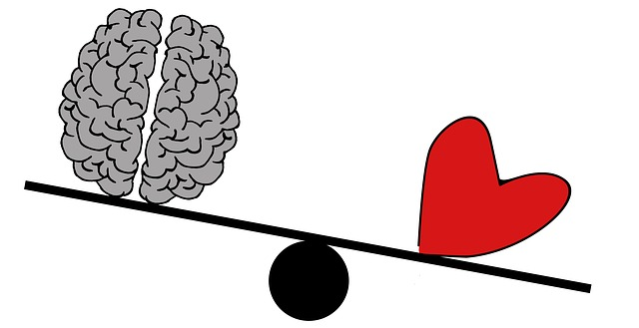

“We tend to think that we have rational relationships to information, but we don’t. We have emotional relationships to information, which is why the most effective disinformation draws on our underlying fears and worldviews….We’re less likely to be critical of information that reinforces our worldview or taps into our deep-seated emotional responses” (Wardle, qtd. in Vongkiatkajorn; emphasis added).

Background
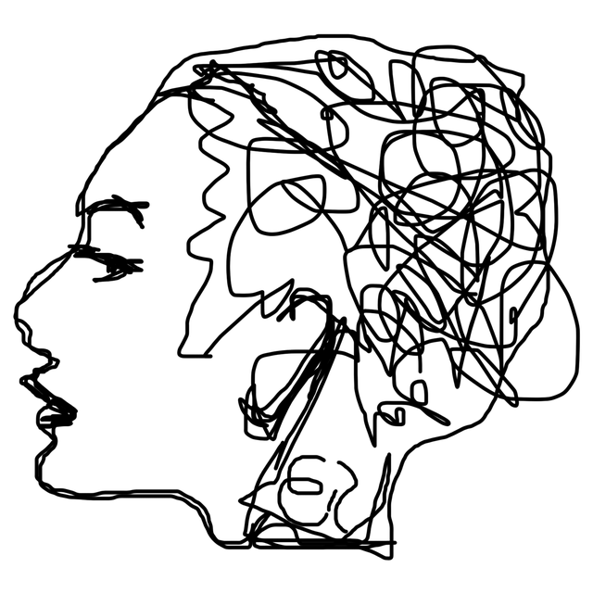
In an information environment shaped by pervasive algorithms, the attention economy, engagement, and polarization, how do we determine truth? How do we know which sources of information to trust? These questions are becoming increasingly difficult to answer, and even more so as “disinformation that is designed to provoke an emotional reaction can flourish in these spaces” (Wardle).
Indeed, in 2016, Oxford Dictionaries selected post-truth as the Word of the Year, defining this as: “relating to or denoting circumstances in which objective facts are less influential in shaping public opinion than appeals to emotion and personal belief.”

Trust
A 2020 study from Project Information Literacy confirms that the way information is delivered today—with opinion and propaganda mingled with traditional news sources, and with algorithms highlighting sources based on engagement rather than quality—has left many college students concerned about the trustworthiness of online content. Students reported that it was difficult to know where to place their trust when credible sources are buried by a deluge of poorer-quality content and misinformation. One student noted that “it’s not that we’re lacking credible information. It’s that we’re drowning in like a sea of all these different points out there” (Head et al. 20).

“This is happening at a time when falsehoods proliferate and trust in truth-seeking institutions is being undermined. Even the very existence of truth itself has come into question….People no longer know what to believe or on what grounds we can determine what is true” (Head et al. 11, 36).

Essential Definitions
First, it is important to establish a shared vocabulary and terminology so that we can better understand and discuss these concepts. Claire Wardle, a world-renowned expert in this field, has used “information disorder” as an umbrella term for the various types of false, misleading, manipulated, or deceptive information we have seen flourish in recent years. She also created an essential glossary for information disorder, with definitions for related words and phrases. For example, you will find helpful definitions for terms like algorithm, bots, data mining, deepfakes, doxing, sock puppet, and trolling.
The graphic below illustrates the scale and range of intent behind false information, from unintentionally inaccurate to deliberately deceptive and harmful. For a much more detailed explanation of each form of information disorder, from “satire” to “fabricated content” to “false context,” see First Draft’s Essential Guide to Understanding Information Disorder.
Text version of this Venn diagram

Sources
“First Draft’s Essential Guide to Understanding Information Disorder” by Claire Wardle is licensed under CC BY-NC-ND 4.0
Head, Alison J., Barbara Fister, and Margy MacMillan. “Information Literacy in the Age of Algorithms.” Project Information Literacy, 15 Jan. 2020. Licensed under CC BY-NC-SA 4.0
Image: “3 Types of Information Disorder” graphic by Claire Wardle & Hossein Derakshan is licensed under CC BY-NC-ND 3.0
Image: “Cognition and Emotion” by ElisaRiva on Pixabay
Image: “Line Mind” by ElisaRiva on Pixabay
“Oxford Word of the Year 2016.” Oxford Languages, Oxford University Press.
Vongkiatkajorn, Kanyakrit. “Here’s How You Can Fight Back Against Disinformation.” Mother Jones, 9. Aug. 2018.
Wardle, Claire. “Information Disorder, Part 1: The Essential Glossary.” First Draft, 9 July 2018.

Chapter 11

Web Evaluation Skills: A “Bleak” Track Record

“At present, we worry that democracy is threatened by the ease at which disinformation about civic issues is allowed to spread and flourish” (Wineberg et al., “Evaluating Information”).
How are we doing when it comes to recognizing disinformation and navigating the information disorder landscape?

Web Evaluation Skills: Students

In 2016, a few months before the U.S. Presidential election, an influential study on Web literacy was completed by the Stanford History Education Group. Their report—titled “Evaluating Information: The Cornerstone of Civic Online Reasoning”—was concerned with the spread of disinformation online, and how this might threaten our democracy. The study asked nearly 8,000 students (in middle school, high school, and college) to perform five Web evaluation tasks. The results were quite shocking:
- 80% of students couldn’t distinguish “sponsored content” from news articles on websites
- 67% of students failed to recognize potential bias in online information
- 65% of students took online images at face value
- Almost all struggled to evaluate information on social media.
In 2019, as yet another U.S. Presidential election approached, the Stanford History Education Group conducted a similar study of civic online reasoning, this time with a sample of 3,446 high school students. The results?
- 52% of students believed a grainy video shot in Russia constituted “strong evidence” of voter fraud (ballot stuffing) in the U.S.
- Two-thirds of students couldn’t tell the difference between news stories and ads (“Sponsored Content”)
- 96% of students did not consider how bias impacts website credibility (for example, ties between a climate change website and the fossil fuel industry).
These studies conclude by describing student’s ability to reason about the information as either “bleak” or “troubling” (Wineberg et al., “Evaluating Information”; Breakstone et al.).
However, as we will see below, this trouble is not just limited to students.

Web Evaluation Skills: “Experts”

In 2017, the Stanford History Education Group conducted a study, “Lateral Reading: Reading Less and Learning More When Evaluating Digital Information.” Here, they assessed the Web evaluation skills of presumed experts: Stanford undergraduates, History professors, and professional fact-checkers. This fascinating study confirmed that even Stanford students and professors with PhDs in History struggled to identify credible sources on the Web.
For example, in one task, the participants were presented with two websites that provided information on bullying, and they were given up to ten minutes to determine which was the more reliable site. One of the websites (American Academy of Pediatrics) was from the largest professional organization of pediatricians in the world, while the other site (American College of Pediatricians) had been labeled a hate group because of its virulently anti-gay stance. The result?
- Only 50% of the historians identified the reliable website
- Only 20% of the undergrads identified the reliable website
- 100% of the fact-checkers were able to quickly identify the reliable website (Note: For effective strategies, see the chapter on Fact-Checking)

Sources
Breakstone, Joel, et al. “Students’ Civic Online Reasoning: A National Portrait.” Stanford Digital Repository, 14 Nov. 2019. Licensed under CC BY-NC-ND 3.0
Image: “College Student” by Gan Khoon Lay, adapted by Aloha Sargent, is licensed under CC BY 4.0
Image: “Users” by Wilson Joseph, adapted by Aloha Sargent, is licensed under CC BY 4.0
Wineburg, Sam, Sarah McGrew, Joel Breakstone, and Teresa Ortega. “Evaluating Information: The Cornerstone of Civic Online Reasoning.” Stanford Digital Repository, 22 Nov. 2016. Licensed under CC BY-NC-ND 3.0
Wineburg, Sam, and Sarah McGrew. “Lateral Reading: Reading Less and Learning More When Evaluating Digital Information.” Stanford History Education Group Working Paper No. 2017-A1, 6 Oct. 2017, dx.doi.org/10.2139/ssrn.3048994.

Chapter 12

Information Cynicism
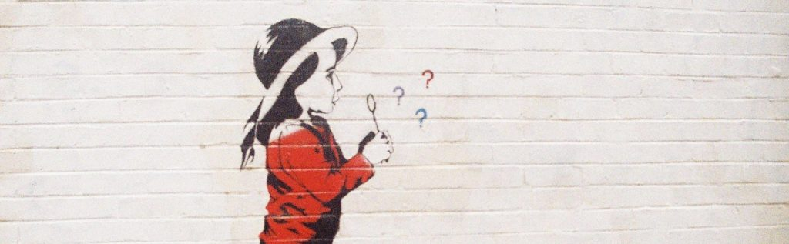

Skepticism vs. Cynicism

“While skepticism is healthy, cynicism—real cynicism—is toxic” (“Astroturfing: Last Week Tonight with John Oliver”).
As defined by the Oxford English Dictionary:
- Skeptical: Not easily convinced; having doubts or reservations
- Cynical: Believing that people are motivated purely by self-interest; distrustful of human sincerity or integrity
When it comes to information you encounter in your personal, professional, or academic research, a skeptical approach can be productive. For example, information skeptics might take a moment to fact-check, verify, or investigate a source before using or sharing it.
However, when skepticism turns to cynicism and deep distrust, research can become unproductive. Information cynics may feel powerless to identify reliable and useful sources. That is, while learning to question everything, they have begun to believe nothing—even highly-credible sources of information.

“Without feeling empowered to sort fiction on the web, a lot of students are merely cynical and believe they can’t trust anything” (Caulfield, qtd. in Young; emphasis added).

Sources
“Astroturfing: Last Week Tonight with John Oliver.” YouTube, uploaded by LastWeekTonight, 12 Aug. 2018.
“Cynical.” Lexico, Oxford.
Image: “Painting on wall of girl blowing question marks” by Matthew Paul Argall is licensed under CC BY 2.0
“Skeptical.” Lexico, Oxford.
Young, Jeffrey R. “Can a New Approach to Information Literacy Reduce Digital Polarization?” EdSurge, 22 Mar. 2018.

Chapter 13

College Students and Cynicism

“It is really hard to know what is real in today’s society; there are a lot of news sources and it is difficult to trust any of them” (Anonymous student qtd. in Head et al., “How Students Engage With News,” 14).
Project Information Literacy, a nonprofit research institute that studies what it is like to be a student in the digital age, has published a number of influential reports that illustrate the rise in information cynicism among college students.

An “Increasing Avalanche” of Information
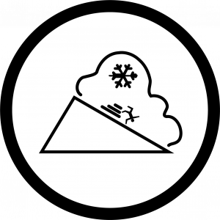
In 2018, they conducted a study of almost 6,000 students at 11 U.S. colleges (Head et al., “How Students Engage With News”), finding that:
- 82% of students said that news is necessary in a democracy
- 72% get news from social media on a daily basis
- 68% said the sheer amount of news available to them was overwhelming
- 45% found it difficult to tell real news from “fake news”
- 36% said “fake news” had made them distrust the credibility of any news
- “Deep political polarization” had made students “suspicious of biased reporting”
- Students were highly critical of an “increasing avalanche” of news that “appeals to emotions rather than conveying credible facts.”

“Super Cynical:” A Lack of Trust
Information cynicism was explored more deeply in their 2020 report based on student focus groups and faculty interviews at eight U.S. colleges (Head et al., “Information Literacy”). This study found that:
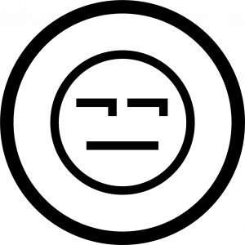
- Students were cynical almost to the point of believing their concerns and actions had little meaning, and that it was not possible to change things
- An important theme was that “no news source could be trusted at face value” and there was a pervasive belief among students that they should “rely on themselves” to decide what to believe
- Many students felt they had been taught to be critical of everything they encountered, which even extended to the authority of their teachers. One student noted: “We’re all super cynical and untrusting of information to the point that we want to find it out ourselves, so if a teacher says, ‘There’s five rows,’ then we actually look, and, yep, there’s five rows.”
Interestingly, the study found that as a whole, this lack of trust in traditional authority figures meant that trust was placed in Google as the arbiter of truth—a dangerous conclusion, given the nature of algorithms. One student who was also a parent described how he had tried to explain to his child that the bogeyman was not real, but his child had not believed him until a Google search confirmed it!

Sources
Head, Alison J., Barbara Fister, and Margy MacMillan. “Information Literacy in the Age of Algorithms.” Project Information Literacy, 15 Jan. 2020. Licensed under CC BY-NC-SA 4.0
Head, Alison J., John Wihbey, P. Takis Metaxas, Margy MacMillan, and Dan Cohen. “How Students Engage with the News: Five Takeaways for Educators, Journalists, and Librarians.” Project Information Literacy, 16 Oct. 2018. Licensed under CC BY-NC-SA 4.0
Image: “Avalanche” by Lorenzo Stella, adapted by Aloha Sargent, is licensed under CC BY 4.0
Image: “Suspicious” by Freepik, adapted by Aloha Sargent, from Flaticon.com

Chapter 14

Information Hygiene and Info-Environmentalism


Information Hygiene
The term information hygiene refers to the “metaphorical handwashing you engage in to prevent the spread of misinformation” (Caulfield, “It Can Take”).
This idea has gained prominence in recent years, and particularly during the COVID-19 pandemic, as we have witnessed a massive outbreak of misinformation, disinformation, hoaxes, and conspiracies surrounding this coronavirus. The World Health Organization (WHO) and other experts have even referred to the COVID-19 pandemic as an “infodemic”—an epidemic of information. In their February 2020 Novel Coronavirus Situation Report, the WHO noted that the COVID-19 outbreak and response “has been accompanied by a massive ‘infodemic’—an over-abundance of information—some accurate and some not—that makes it hard for people to find trustworthy sources and reliable guidance when they need it.”
This is a stark example of the real-world impact that our online information can have. In this case, false information that we view, “like,” and share can actually help to shape the public perceptions about the pandemic, as well as our responses and decisions about how to behave. Can you think of any other recent examples that demonstrate the real-world impact of disinformation?
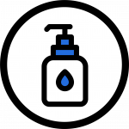
So, the message here is that, in addition to actual hygiene, we also need to focus on information hygiene and “flattening the curve of dangerous falsehoods online by taking proactive steps to reduce their spread” (“Practice Information Hygiene”). Fact-checking, which we will discuss in the next chapter, is an example of good information hygiene. Much like hand sanitizer or hand washing, it isn’t a cure, but rather a prevention for the spread of misinformation (Caulfield, “Misinformation”).

Info-Environmentalism
The idea behind “info-environmentalism” is that if our information environment is polluted, we shouldn’t abandon it—instead, we should help to clean it up. That is, if we are frustrated with the content posted on platforms like Facebook or YouTube or with low-quality Google search results, why not clean it up by posting as much reliable information as we can?
Of course, a big part of this movement will involve putting pressure on the platforms themselves to act responsibly. But because the Web is a collectively-maintained and produced environment, we, as consumers and creators, can also participate in the process through direct action. Here are some examples of actions you might take to improve the information environment (Caulfield, “Info-Environmentalism”):

- Minimize your own “misinformation footprint” by being more thoughtful about what you post and share on social media. Do a quick fact-check first.
- Shift your focus from arguing points to explaining things to others.
- Edit and improve Wikipedia articles.
- Create explanatory YouTube videos.
- Post pages on blogs or wikis that provide helpful guidance on important issues.
- Post better answers on question-and-answer websites like Quora or StackExchange.
- When you do share information, use evidence and cite your sources.

Sources
Caulfield, Mike. “Info-Environmentalism: An Introduction.” EDUCAUSE Review, vol. 52, no. 6, Nov/Dec. 2017. Licensed under CC BY 4.0
Caulfield, Mike. “It Can Take As Little as Thirty Seconds, Seriously.” Hapgood, 23 Jan. 2018.
Caulfield, Mike. “Misinformation Is a Norovirus and the Web Is a Cruise Ship.” Hapgood, 17 Feb. 2017.
Image: “Hand Sanitizer” by Freepik, adapted by Aloha Sargent, from Flaticon.com
Image: “Recycle” by Freepik, adapted by Aloha Sargent, from Flaticon.com
Image: “Wash Your Hands” by United Nations COVID-19 Response is in the Public Domain, CC0
“Novel Coronavirus(2019-nCoV): Situation Report – 13.” World Health Organization, 2 Feb. 2020.
“Practice Information Hygiene.” The Sift, News Literacy Project, 16 Mar. 2020.

Chapter 15

Conclusion
This chapter covered information disorder, information cynicism, information hygiene, info-environmentalism, and the broad psychological, physiological, and sociological effects of disinformation. A common thread runs through all of these concepts in that they focus on the behaviors and actions that we should take not only when consuming but also when sharing information.
In other words, our goal should be to:
- Minimize our own exposure to information disorders like misinformation and disinformation, and
- Avoid spreading those information disorders to others.

Sources
Image: “Rainbow Frequency” by Ricardo Gomez Angel is in the Public Domain, CC0

PART IV

Fact-Checking

Learning Objectives
By the end of this chapter, you will be able to:
- Identify effective strategies for fact-checking sources
- Investigate a source of information to determine reliability
- Find better coverage for a source of information
- Trace claims, quotes, and media to their original context

Chapter 16

Why Fact-Checking?

Introduction
When you find a source of information, how do you know if it’s true? How can you be sure that it is a reliable, trustworthy, and effective piece of evidence for your research? This chapter will introduce you to a set of strategies to quickly and effectively verify your sources, based on the approach taken by professional fact-checkers. Fact-checking is a form of information hygiene—it can minimize your own susceptibility to misinformation and disinformation, and help you to avoid spreading it to others.
As an introduction, please watch the following video [3:13], which discusses the results of a very interesting study of Stanford students, historians, and professional fact-checkers (Wineburg and McGrew). Which group do you think did the best job of identifying reliable sources?
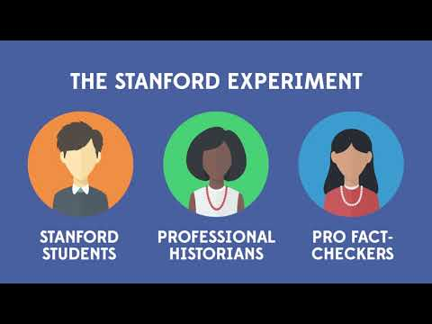
A YouTube element has been excluded from this version of the text. You can view it online here: https://oer.pressbooks.pub/collegeresearch/?p=87
Note: Turn on closed captions with the “CC” button or use the text transcript if you prefer to read.

Sources
“Online Verification Skills – Video 1: Introductory Video.” YouTube, uploaded by CTRL-F, 29 June 2018.
Wineburg, Sam, and Sarah McGrew. “Lateral Reading: Reading Less and Learning More When Evaluating Digital Information.” Stanford History Education Group Working Paper No. 2017-A1, 6 Oct. 2017, dx.doi.org/10.2139/ssrn.3048994.

Chapter 17

The SIFT Method
Mike Caulfield, Washington State University digital literacy expert, has helpfully condensed key fact-checking strategies into a short list of four moves, or things to do to quickly make a decision about whether or not a source is worthy of your attention. It is referred to as the “SIFT” method:
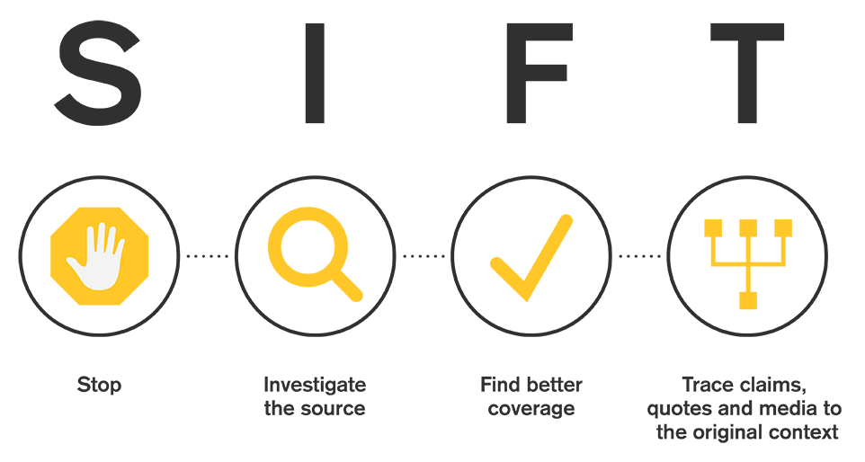

Stop

When you initially encounter a source of information and start to read it—stop. Ask yourself whether you know and trust the author, publisher, publication, or website. If you don’t, use the other fact-checking moves that follow, to get a better sense of what you’re looking at. In other words, don’t read, share, or use the source in your research until you know what it is, and you can verify it is reliable.
This is a particularly important step, considering what we know about the attention economy—social media, news organizations, and other digital platforms purposely promote sensational, divisive, and outrage-inducing content that emotionally hijacks our attention in order to keep us “engaged” with their sites (clicking, liking, commenting, sharing). Stop and check your emotions before engaging!

Investigate the Source

You don’t have to do a three-hour investigation into a source before you engage with it. But if you’re reading a piece on economics, and the author is a Nobel prize-winning economist, that would be useful information. Likewise, if you’re watching a video on the many benefits of milk consumption, you would want to be aware if the video was produced by the dairy industry. This doesn’t mean the Nobel economist will always be right and that the dairy industry can’t ever be trusted. But knowing the expertise and agenda of the person who created the source is crucial to your interpretation of the information provided.
When investigating a source, fact-checkers read “laterally” across many websites, rather than digging deep (reading “vertically”) into the one source they are evaluating. That is, they don’t spend much time on the source itself, but instead they quickly get off the page and see what others have said about the source. They open up many tabs in their browser, piecing together different bits of information from across the web to get a better picture of the source they’re investigating.
Please watch the following short video [2:44] for a demonstration of this strategy. Pay particular attention to how Wikipedia can be used to quickly get useful information about publications, organizations, and authors.
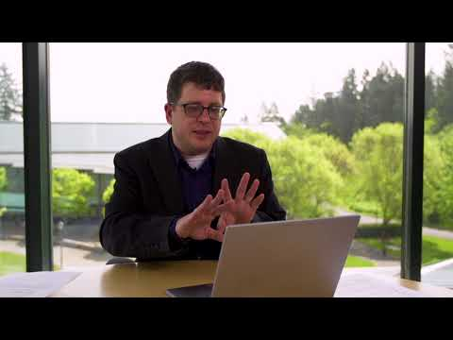
A YouTube element has been excluded from this version of the text. You can view it online here: https://oer.pressbooks.pub/collegeresearch/?p=94
Note: Turn on closed captions with the “CC” button or use the text transcript if you prefer to read.

Find Better Coverage

What if the source you find is low-quality, or you can’t determine if it is reliable or not? Perhaps you don’t really care about the source—you care about the claim that source is making. You want to know if it is true or false. You want to know if it represents a consensus viewpoint, or if it is the subject of much disagreement. A common example of this is a meme you might encounter on social media. The random person or group who posted the meme may be less important than the quote or claim the meme makes.
Your best strategy in this case might actually be to find a better source altogether, to look for other coverage that includes trusted reporting or analysis on that same claim. Rather than relying on the source that you initially found, you can trade up for a higher quality source.
The point is that you’re not wedded to using that initial source. We have the internet! You can go out and find a better source, and invest your time there. Please watch this video [4:10] that demonstrates this strategy and notes how fact-checkers build a library of trusted sources they can rely on to provide better coverage.
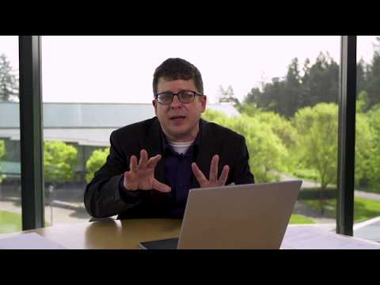
A YouTube element has been excluded from this version of the text. You can view it online here: https://oer.pressbooks.pub/collegeresearch/?p=94
Note: Turn on closed captions with the “CC” button or use the text transcript if you prefer to read.

Trace Claims, Quotes, and Media to the Original Context

Much of what we find on the internet has been stripped of context. Maybe there’s a video of a fight between two people with Person A as the aggressor. But what happened before that? What was clipped out of the video and what stayed in? Maybe there’s a picture that seems real but the caption could be misleading. Maybe a claim is made about a new medical treatment based on a research finding—but you’re not certain if the cited research paper actually said that. The people who re-report these stories either get things wrong by mistake, or, in some cases, they are intentionally misleading us.
In these cases you will want to trace the claim, quote, or media back to the source, so you can see it in its original context and get a sense of whether the version you saw was accurately presented. Please watch the following video [1:33] that discusses re-reporting vs. original reporting and demonstrates a quick tip: going “upstream” to find the original reporting source.
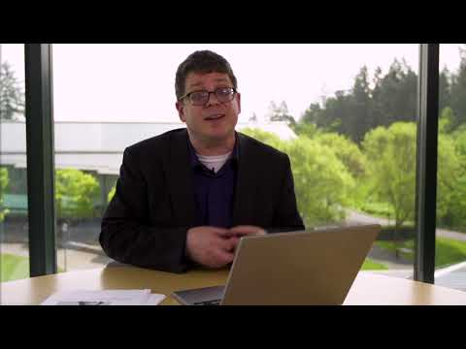
A YouTube element has been excluded from this version of the text. You can view it online here: https://oer.pressbooks.pub/collegeresearch/?p=94
Note: Turn on closed captions with the “CC” button or use the text transcript if you prefer to read.

Sources
“Online Verification Skills – Video 2: Investigate the Source.” YouTube, uploaded by CTRL-F, 29 June 2018.
“Online Verification Skills – Video 3: Find the Original Source.” YouTube, uploaded by CTRL-F, 25 May 2018.
“Online Verification Skills – Video 4: Look for Trusted Work.” YouTube, uploaded by CTRL-F, 25 May 2018.
SIFT text adapted from “Check, Please! Starter Course,” licensed under CC BY 4.0
SIFT text and graphics adapted from “SIFT (The Four Moves)” by Mike Caulfield, licensed under CC BY 4.0

Chapter 18

Using Wikipedia Effectively

“To tell students not to use Wikipedia is to deprive them of one of the most useful tools on the Internet. Instead of teaching them to avoid it, we should be teaching students how to use Wikipedia wisely” (“How to Use Wikipedia Wisely”).

Misconceptions & Benefits
Wikipedia—the world’s largest reference website—is broadly misunderstood. Because it is written by thousands of anonymous volunteers around the world, Wikipedia generates uncertainty or skepticism in many. If just anyone can change Wikipedia, won’t there be inaccuracies? Won’t people potentially abuse that power?
The open, collaborative approach of Wikipedia means that it is susceptible to vandalism, unverified information, or subtle viewpoint promotion. However, that same open approach also increases the chances that factual errors and misleading statements will be quickly corrected, and that articles will be consistently improved and updated. Indeed, an often-cited 2005 study (Giles), as well as a follow-up study in 2012 (Casebourne et al.), found no significant differences in accuracy between Wikipedia and Encyclopaedia Britannica articles.

Additionally, the Wikipedia community has strict rules about providing citations or references for facts and claims, and authors must adopt a neutral point of view. Because of this, Wikipedia articles are often the best available introduction to a subject. If you are researching a complex question, starting with the resources and summaries provided by Wikipedia can give you a substantial running start on an issue. For more information about this, see the section on Background Reading. The requirement for Wikipedia authors to cite their sources has another beneficial effect. If you can find a claim expressed in a Wikipedia article, you can almost always follow the footnotes to reliable sources for further research and evidence.

Areas for Caution
Not all Wikipedia articles are useful. Some articles are incomplete or contain “citation needed” warnings. You may find very short “stub” articles that are awaiting either further expansion, or deletion. You should avoid using these types of articles for your research.
Another known concern is systemic bias in Wikipedia, including gender and racial bias. For example, of the over 130,000 active editors of Wikipedia, only 8.5% to 16% are female; of the over 1.5 million biographies on Wikipedia, only 18% are about women (Kantor). Wikipedia has launched numerous initiatives to encourage more women to become editors and to improve their coverage of women; even so, the gender gap persists. With Wikipedia as well as other, more traditional forms of publishing, we must be aware of who creates the information we consume, and understand how that impacts our knowledge about research topics and the world around us. For more on bias, see the page on Information Sources: Bias.

Using Wikipedia Wisely
With an awareness of these benefits and concerns, you can more effectively use Wikipedia for fact-checking and to find background information on a topic. Please watch the following video [2:41] that addresses some of the common misconceptions about Wikipedia and demonstrates how you can use this tool wisely, as professional fact-checkers often do.
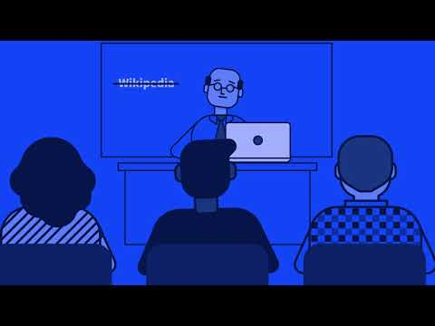
A YouTube element has been excluded from this version of the text. You can view it online here: https://oer.pressbooks.pub/collegeresearch/?p=97
Note: Turn on closed captions with the “CC” button or use the text transcript if you prefer to read.

Sources
Casebourne, Imogen, et al. “Assessing the Accuracy and Quality of Wikipedia Entries Compared to Popular Online Encyclopaedias: A Comparative Preliminary Study Across Disciplines in English, Spanish and Arabic.” Wikimedia, Epic and Univ. of Oxford, 2012. Licensed under CC BY-SA 3.0.
Giles, Jim. “Internet Encyclopaedias Go Head to Head.” Nature, vol. 438, 2005, pp. 900–901, doi.org/10.1038/438900a.
“How to Use Wikipedia Wisely.” YouTube, uploaded by Stanford History Education Group, 23 Jan. 2020.
Image: “Run” by Alex Podolsky, adapted by Aloha Sargent, is licensed under CC BY 4.0
Kantor, Jessica. “Wikipedia Still Hasn’t Fixed Its Colossal Gender Gap.” Fast Company, 13 Nov. 2019.
Misconceptions and Benefits section adapted from “Web Literacy for Student Fact-Checkers” by Mike Caulfield, licensed under CC BY 4.0 and “Teaching with Wikipedia: A High Impact Open Educational Practice” by TJ Bliss, licensed under CC BY-NC-SA 4.0

Chapter 19

Fact-Checking Images and Memes

Find Trusted Coverage
Often, claims or stories will come to you in the form of images and memes. How do you know if images have been digitally altered (Photoshopped) or if they are being shared out of context (misrepresented)?
If you want to find trusted coverage of the issue, claim, or photo, you have two options:
- You can search the relevant text from the image
- You can use “reverse image search”

Reverse Image Search Using Google

On your Computer
Using Chrome as your browser, right-click the image and select “Search Google for image.” Note: On a Mac, use Control-click. On a Chromebook, use Alt-click.
In the example below, we can do a reverse image search on this meme that suggests space lasers were responsible for the California wildfires.

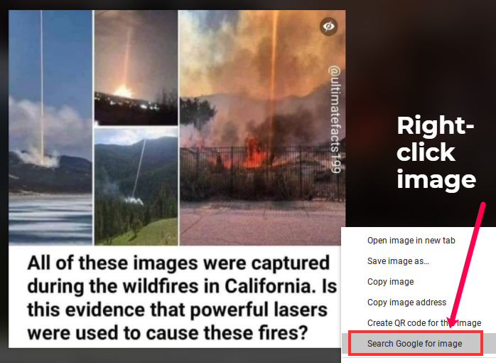

On your Phone
Using Chrome (app), touch and hold the image, then select “Search Google for This Image” Note: You may first have to click a menu option to “Open in Chrome”
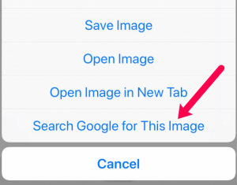

The Results
You will get a list of any other websites where the image has been used, including previous fact-checks of the image, and perhaps even a link to the real version of the photo.
In our example, we see that this meme has appeared in many other places, and that it has already been shown to be false by a reputable fact-checking organization.
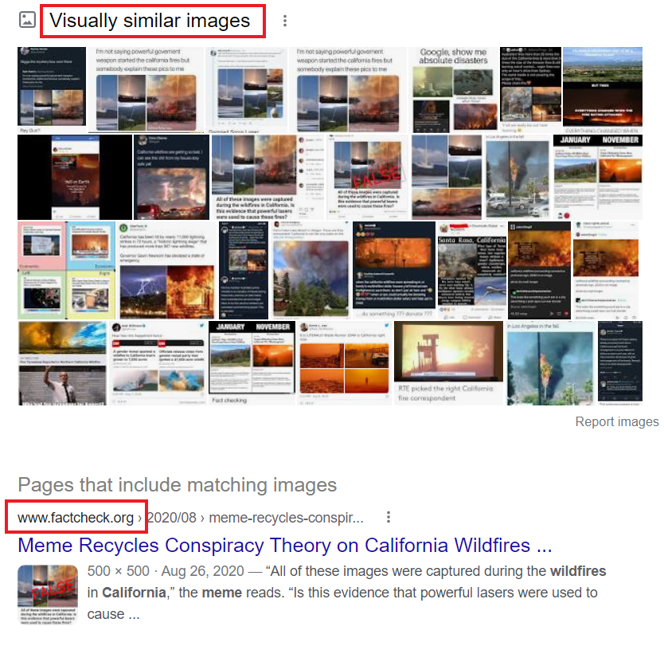
The results of this fact-checking led to some of the actual images, in context. In the screenshot below from the Twitter account for SpaceX, we see that the first image from the meme was actually an image of a SpaceX rocket launch, not a laser beam hitting California.
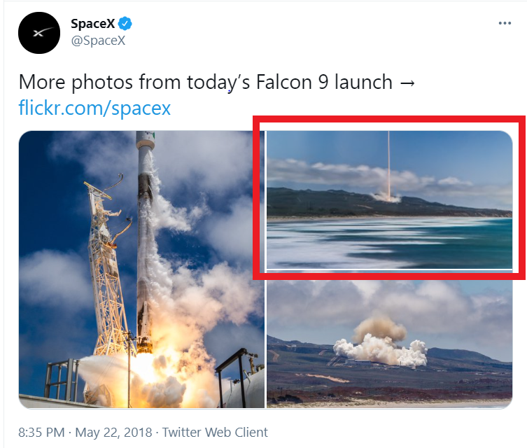

Sources
Find Trusted Coverage section adapted from “Check, Please! Starter Course,” licensed under CC BY 4.0
Reverse Image Search section adapted from “Library 10” by Cabrillo College Library, licensed under CC BY 4.0

Chapter 20

Conclusion
There’s a theme that runs through all of these fact-checking moves: They are about reconstructing the necessary context to verify, understand, and interpret sources of information that we may encounter in academic, professional, and personal research.
One piece of context is the author or publisher. What’s their expertise? What’s their agenda? This will require investigating the source.
When it comes to claims, a key piece of context includes whether they are accepted or contested. By scanning for other coverage, you can see what the consensus is on a claim and perhaps find a better source.
Finally, when evidence is presented through a certain lens—whether a quote or an image or a scientific finding—sometimes it helps to reconstruct the original context in which the evidence was presented.
In some cases these techniques will show you that claims are false, or that sources are misleading or even deceptive. But in the majority of cases they do something just as important: They reestablish the context that the web so often strips away, allowing for more meaningful engagement with information.

Sources
Image: “Rainbow Frequency” by Ricardo Gomez Angel is in the Public Domain, CC0
Text adapted from “SIFT (The Four Moves)” by Mike Caulfield, licensed under CC BY 4.0

PART V

Types of Information Sources

Learning Objectives
By the end of this chapter, you will be able to:
- Identify and describe different types of information sources
- Recognize when it is best to use specific types of sources

Chapter 21

Chapter Scenario

Scenario: Information Sources
It’s your first essay assignment of the semester. Your professor says you not only have to find reliable sources, but that you have to use a variety of resources: books, magazines, newspapers, journal articles, and media resources. There’s no explanation why they are requiring this, and you’re left scratching your head trying to figure out not just where to find these resources, but why they make a difference.

Chapter 22

Information Sources: Primary, Secondary, Tertiary

Information Creation & Context
We can group information sources into three basic categories: primary, secondary, and tertiary. When we make distinctions between these three categories of sources, we are relating the information itself to the context in which it was created. Noting this relationship between creation and context helps us understand the big picture in which information operates, and prompts us to consider whose voices we are including in our research, and whose voices may be left out.

Primary Sources
Primary sources are first-hand observations or experiences of an event. They can also be the original sources of information before they have been analyzed, such as statistical data sets. Examples of primary sources include:
- Eyewitness reports (interviews, photographs)
- Speeches, diaries, memoirs
- Empirical research
- Original documents, historical newspaper articles
- Literary works (novels, plays, poems), artworks
- Tweets

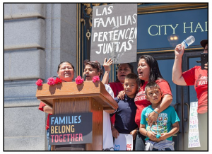

Secondary Sources
Secondary sources are created after an event occurred and offer a review or an analysis of the event; they provide an interpretation of the primary source or data without offering new data. Examples of secondary sources would be:
- Biographies, nonfiction books
- Editorials
- Literary criticism and reviews
- Periodicals (such as scholarly journals, magazines, or newspapers)
- Retweets


Tertiary Sources
Tertiary sources are compilations of information coming from secondary and primary sources; these can be lists or collections, and are generally reference material that can help you find, or direct you to, secondary and primary sources. Examples of tertiary sources include:
- Encyclopedias, dictionaries
- Indexes
- Databases, catalogs
- Most textbooks
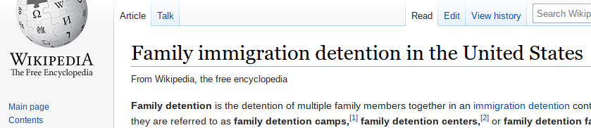
Note: These categories may differ between subject areas. For details, see section on Information Sources: Traditional Formats.

Sources
Creation & Context section adapted from “Primary, Secondary & Tertiary Sources” by Teaching & Learning, Ohio State University Libraries, licensed under CC BY 4.0
Examples adapted from “Library 10” by Cabrillo College Library, licensed under CC BY 4.0
Image: “Families Belong Together SF march” by Pax Ahimsa Gethen is licensed under CC BY-SA 4.0
Image: “World of Walls: The Structure, Roles and Effectiveness of Separation Barriers” by Said Saddiki is licensed under CC BY 4.0

Chapter 23

Critical Thinking

Critical Thinking: Source Types
Let’s think about these categories a little more. When conducting research, it is often suggested that we begin looking at tertiary sources, then secondary, and finally primary. But when resources are created, it starts with primary, then secondary, and finally tertiary. Why do you think this relationship exists between research and creating resources? Are there any other ways that you can see information sources being created or to conduct research?

Chapter 24

Information Sources: Traditional Formats
As we saw in the chapter scenario, information sources are often identified by traditional formats: is the information found in a book, a scholarly journal article, or a magazine or newspaper article? Outside of these typically being classified as secondary sources (particularly in the humanities), these traditional formats have a few other commonalities: they all tend to be trustworthy; they go through some sort of publication and review process; and they all are fixed formats—that is, they can’t be updated without creating a whole new version or edition of the resource. They can also be available as print (physical) or digital (online). So, what makes them different or unique?

Books
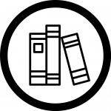
You are probably familiar with this type of information source and it might just be the first kind of resource you think of when you think of libraries. Books are different than the other resources in a few ways: They can explore and present a topic in breadth and depth much easier than a magazine or newspaper. You may find some special magazine issues or journal issues that are devoted to a theme, but the coverage will still be limited compared to a book’s possibility. Books can be written by a single author or multiple authors; they can be compiled by an editor to represent different viewpoints or writings from various authors all exploring the same topic from different angles. Because of all of this, though, the information found in books may not be the most current information available.

Academic/Scholarly Journal Articles

Sometimes also called “peer-reviewed” articles, these go through a rigorous review process before they are published. They reflect research that is considered primary or secondary depending on how the research is conducted: In the humanities (such as English or History), these are considered secondary sources, but in the sciences (such as Biology) and social sciences (such as Anthropology), original research articles are considered primary sources. Unlike books, these journal articles tend to focus on specific questions about a topic; they don’t explore or present a topic as broadly or deeply as a book, but the information they present can be much more current than a book. Also, because they are so focused, they might be seen as more specialized than a book’s coverage, and they will generally be written to an expert audience. This means that they are not written for the average person to read, but for those who are already familiar with the concepts surrounding the topic. Their target audience are others who have some expertise in a specific subject area—even though undergraduates are often required to use them too. Another thing to consider is that access to journal articles can be tricky. If your library doesn’t have access to a particular journal, either through a database or direct subscription, getting access on your own could be expensive and complicated (though as a community college student, you’re not usually expected to pursue resources beyond your college library).

Magazine Articles
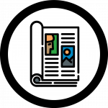
These are a bit different than your academic/scholarly journal articles. Magazines tend to use a lot of colorful images designed to grab a reader’s attention, while scholarly journals feature graphs, charts, and tables with very little color, designed to convey information. Magazine articles will be written so that the average person can understand what is being discussed in the article. The articles tend to be much shorter than a scholarly journal article. Magazine articles can feature interviews and will look at current events or trends, but they won’t be seeking answers to research-based questions. Instead, their focus is on what might hold popular interest.

Newspaper Articles

Newspaper articles typically describe current events. In contrast to magazine and scholarly journal articles, newspaper articles tend to be very short. Newspapers are typically published daily, and therefore provide the most up-to-date information about an event. Their authors are journalists who may engage in investigative reporting, but they do not conduct original scholarly research. While these articles are often proofread and reviewed for accuracy before publication, they do not go through an extensive peer review process.

Sources
Image: “Articles” by Freepik, adapted by Aloha Sargent, from Flaticon.com
Image: “Book” by mavadee, adapted by Aloha Sargent, from Flaticon.com
Image: “Magazine” by Freepik, adapted by Aloha Sargent, from Flaticon.com
Image: “Newspaper” by Freepik, adapted by Aloha Sargent, from Flaticon.com

Chapter 25

Information Sources: Media
Media can refer to many things, but here it describes information sources that do not align to our traditional formats (books, magazines). These are usually visual in nature (such as film), or perhaps audio (such as music). Sometimes, we don’t realize media resources are an option when doing research, but they can be very helpful, and for some cases can be even stronger resources than our traditional formats. Here are a few examples of media resources you might encounter as you conduct your own research projects.

Documentaries
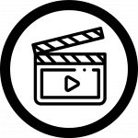
Documentaries are films that provide us with a deep look at a specific topic. Non-fiction in nature, documentaries can advocate for a cause—which means we must be careful to notice any possible bias. They can be journalistic in nature where they report on an event, happening, people, and/or other subjects in detail. They can share an experience someone went through. Documentaries may also be entertaining, so that they are interesting to watch.

Radio Programs (Broadcasts and Interviews)
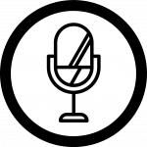
Radio programs can be a strong information source, especially if you’re looking for interviews with specific people. They also report out on current events, but unlike our traditional formats where the information is printed and can be referenced later easily, radio broadcasts are usually one-time events. Fortunately, some of the programs are captured in library databases through transcripts, and other times, you might be able to find recordings of them online.

Television Programs (News and Educational Programming)

News and educational programming can be useful sources when doing research. News programs provide details about current events, and may also broadcast interviews. Educational programming might include documentary-style delivery of information, but it can also be instructive. In some cases, there may be dedicated channels that provide specialized content such as Discovery, The History Channel, and C-SPAN.

Sources
Image: “Microphone” by Freepik, adapted by Aloha Sargent, from Flaticon.com
Image: “Movie” by Freepik, adapted by Aloha Sargent, from Flaticon.com
Image: “Television” by Smashicons, adapted by Aloha Sargent, from Flaticon.com

Chapter 26

Information Sources: Online
The traditional and media formats may also exist online or in digital formats; these can be found through websites or in library databases. But there are other types of sources unique to the online environment that you might want to consider—or not consider—using. Below are just a few of them.

Wikis
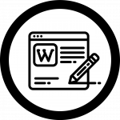
Wikis are a type of website that typically allow a community of users to create pages about different topics. The most popular one, and one that you are probably familiar with, is Wikipedia. These websites are usually very simple in appearance and they are unique because they tend to support the idea of a community contributing to sharing information. With this idea, though, is the possibility for information to be shared without review or checked for reliability. Review the Fact-Checking chapter for further information about how to use Wikipedia effectively.

Blogs
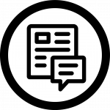
Blogs can house primary source material as they are often like online diaries for individuals. In contrast to wikis, blogs are typically written by a single person, and that individual is typically sharing their perspectives or experiences about a specific topic. These can be insightful, but they are usually very opinion driven. And just because someone has a blog about a topic does not make them an expert about that topic.

Podcasts
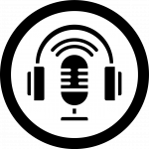
Podcasts continue to grow in popularity, and over half of Americans have listened to at least one podcast (Winn). If you have not experienced a podcast, they are similar to radio programs, except that you don’t have to listen to them live to enjoy them—they can be downloaded or streamed at a time convenient to the listener. You can listen to them in your car or from a capable device, like a smartphone. They can be focused on a specific subject area, contain interviews, or be a fictional series show. But just like blogs, podcasts can be hosted by anyone—and can be driven by opinions and biases.

Sources
Image: “Blog” by Freepik, adapted by Aloha Sargent, from Flaticon.com
Image: “Microphone” by Smashicons, adapted by Aloha Sargent, from Flaticon.com
Image: “Wikipedia” by xnimrodx, adapted by Aloha Sargent, from Flaticon.com
Winn, Ross. “2020 Podcast Stats & Facts (New Research From Oct 2020).” Podcast Insights, Quandary Media, 6 Oct. 2020.

Chapter 27

Critical Thinking

Critical Thinking: Which Resources?
If you have an assignment that requires you to write an essay about the effects of climate change on polar bear populations, what types of resources would you expect to be helpful to use and why? Which resources may not be as helpful?
If you have an assignment that requires you to write an essay about the top 10 music singles in 2019, what types of resources would you expect to be helpful to use and why? Which resources may not be as helpful?

Chapter 28

Information Sources: Bias
Bias has been mentioned a few times in this chapter. Some sources may seem more susceptible to bias than others, but all of them carry some level of bias. So what is bias? According to the Oxford English Dictionary, bias is:
An inclination, leaning, tendency, bent; a preponderating disposition or propensity; predisposition towards; predilection; prejudice.
In other words, bias is a point of view that may influence how information is conveyed. This does not necessarily mean that the information in and of itself is incorrect, but the information may be presented in such a manner that it be interpreted to mean something else or be aligned to specific values. Bias is not always intentional—it can creep into resources without the creators realizing it. So, sometimes, we have to be extra careful when choosing resources and evaluate if there is a bias that is strongly influencing the trustworthiness of the resource that we use.
The image below comes from an organization that evaluates various media organizations or news-based organizations and places them on a scale of how they lean in social affairs: either to the “Right” or “Left,” where “Right-leaning” media organizations will have more conservative views about societal topics, and “Left-leaning” media organizations will have more liberal views about societal topics. You can read more about bias in the media here: Media Bias.

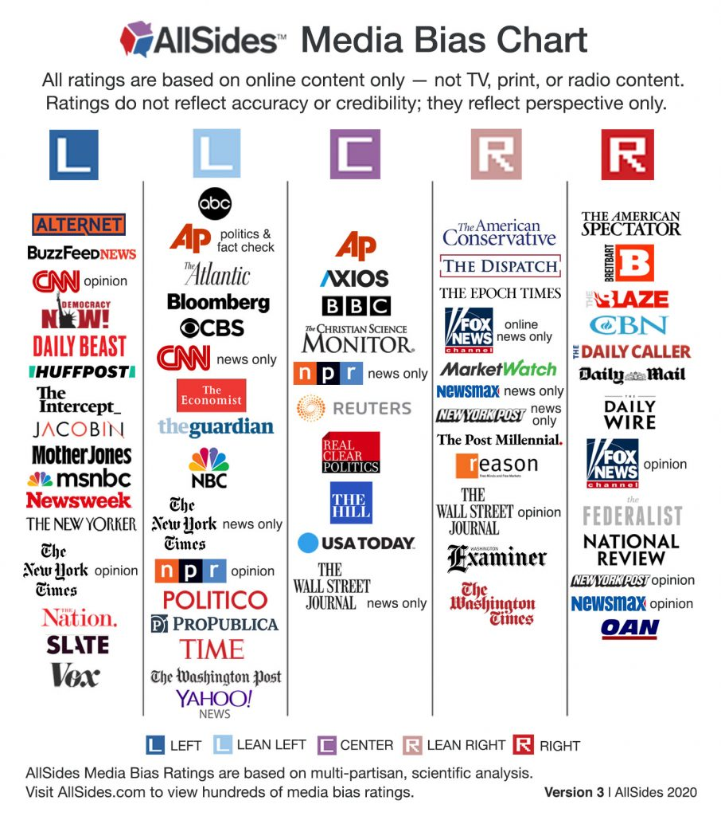

Text description of this infographic

Sources
“bias, adj., n., and adv.” OED Online, Oxford University Press, Sept. 2020.
Image: “AllSides Media Bias Ratings” by AllSides is licensed under CC BY-NC 4.0

Chapter 29

Critical Thinking

Critical Thinking: Bias
How does bias impact the presentation and interpretation of information? What can you do to mitigate that?
How do you recognize when a resource has bias?

Chapter 30

Conclusion
This chapter reviewed different types of information sources. They can be categorized as primary, secondary, or tertiary sources. They can also be identified by different formats, such as books, podcasts, and documentaries. All sources have some level of bias, so it’s important to keep in mind how a resource might be biased and how that might impact your own research.

Sources
Image: “Rainbow Frequency” by Ricardo Gomez Angel is in the Public Domain, CC0

PART VI

Getting Your Research Started

Learning Objectives
By the end of this chapter, you will be able to:
- Develop meaningful research topics
- Explain why gathering background information is important to the research process
- Navigate to the appropriate information sources for background information

Chapter 31

Choosing a Topic

Questions to Consider
When it comes to academic research, choosing a topic is often the hardest part of the process! In many instances, college instructors will provide guidelines or a broad topic for the assignment, but it’s your job to choose a narrower topic within those guidelines. Here are some questions to ask yourself before you decide on a topic to research:
- Have I been assigned a specific topic or can I choose my own?
- Is there a particular current event that interests me or an issue I feel strongly about? Can I select a topic that is closely related to my college major?
- Did the instructor specify what types of information sources I need to use?

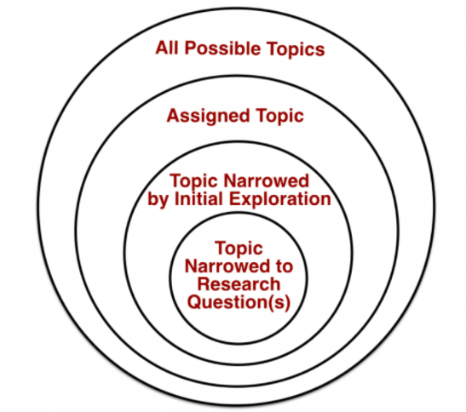

Narrowing Your Topic
It is important to select a topic that not only interests you or sparks your curiosity, but also one that is neither too broad or too narrow in scope. For example, if you are interested in climate change and wanted to choose that as a topic for your research paper, you would quickly find yourself overwhelmed with search results and information. You may find millions of search results about all different aspects of climate change, like policy, history, and the environment, and feel lost about where to begin.
An important step in the research process is narrowing down your larger topic into a smaller, more researchable topic. What is it about climate change that is most interesting to you? Is there something in particular that you’ve learned in class that relates to this topic that you could explore with your research? Watch the following video [3:10] to see how to recognize if your topic is too broad or too specific, and to learn some tips on what to do:

A YouTube element has been excluded from this version of the text. You can view it online here: https://oer.pressbooks.pub/collegeresearch/?p=146
Note: Turn on closed captions with the “CC” button or use the text transcript if you prefer to read.

More Strategies
If you are having trouble selecting a topic or narrowing down your topic, here are some strategies that can help:
- Scan your course textbook for ideas
- Browse some magazines or newspapers for current events
- Dive into Wikipedia, or another encyclopedia, and see what sparks your interest
- Talk to your instructor, a librarian, or classmates, for ideas and guidance
- Browse the “issues” and “topic” pages in library databases that include reference sources, like CQ Researcher or Opposing Viewpoints. These topic pages are similar to Wikipedia and give general background information on a topic and link to more specific information, which is helpful when narrowing down your topic. Some library databases have great features for getting your research started, like pro/con viewpoints, background information, timelines, and bibliographies for further reading. If you are unfamiliar with what library databases your college has a subscription to, ask a librarian for help!
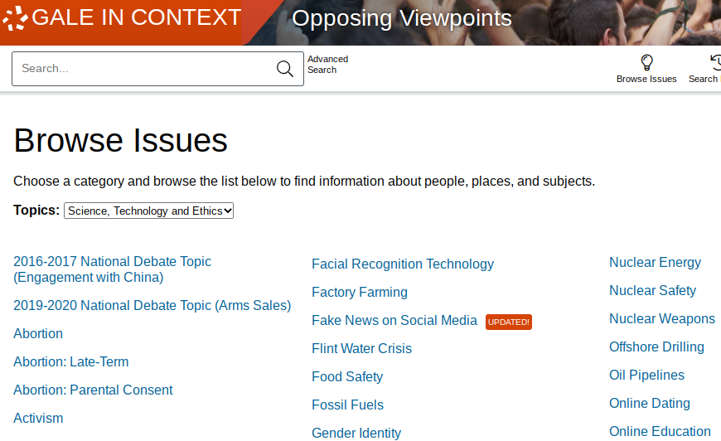
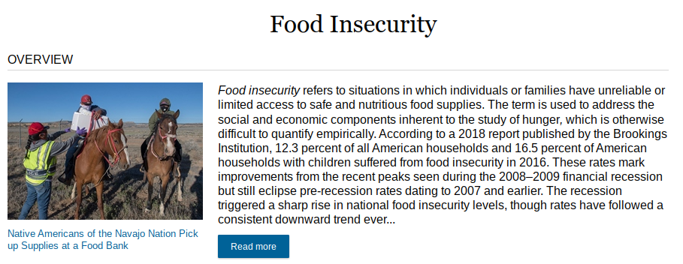

Sources
Image: “Narrowing a Topic” by Teaching & Learning, Ohio State University Libraries is licensed under CC BY 4.0
“Picking Your Topic IS Research” by NC State University Libraries is licensed under CC BY-NC-SA 3.0 US

Chapter 32

Background Reading
Gathering some general information on your research topic by doing background reading is always a great way to begin the research process. Background reading involves reading works related to your topic, in order to get a bigger picture before diving into the deeper research. Similar to how you may consult Google Maps for a general idea of the streets and stores in a new city you plan to visit, background reading can help you feel more informed about where you are going with your research topic.

The Case for Wikipedia
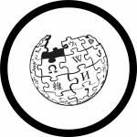
Many people start their research these days with a preliminary Google search, which usually leads them to Wikipedia. Why? Wikipedia and reference sources in general (e.g., encyclopedias, atlases, handbooks) are excellent sources of background information. This is especially helpful if you are assigned or select a topic you are not yet very familiar with. Though Wikipedia is not considered a scholarly or academic source, it can be a great starting point for your research, allowing you to gather general information on your area of interest, and giving you ideas for narrow areas of focus. The “content” box on the left-hand side of Wikipedia pages can help you quickly scan for potentially relevant and interesting subtopics.
Wikipedia use is often discouraged by college professors because anybody can edit information on almost any Wikipedia page (though some pages that are more prone to vandalism have restrictions on who can and cannot edit them). Though the fear of inaccurate information being portrayed on Wikipedia is a legitimate concern, it is also true that Wikipedia is used by millions of people daily and errors are often corrected as soon as they are found. This is especially true on the pages that are used by many, like those for famous people, landmarks, or current events. While many professors will not accept Wikipedia as a source cited in the research assignment you ultimately turn in, it can be a useful tool in the early stages of research when you are seeking background information.
For more information on using Wikipedia to start out your research, and how professional fact-checkers use Wikipedia, refer to the page on Using Wikipedia Effectively.

Sources
Image: “Wikipedia Logotype of Earth Puzzle” by Freepik, adapted by Aloha Sargent, from Flaticon.com

Chapter 33

Conclusion
The very first steps in the research process are oftentimes the most important because they set the groundwork for the rest of your research. This chapter covered the importance of narrowing your broader topic down into a more manageable topic that interests you and the importance of performing some general background reading. Background reading can be done using library databases, Wikipedia, or quick online searches on your topic, which can help you find narrower sub-topics to focus on. Background reading at the beginning of your research helps familiarize you with your topic and with the specific vocabulary and keywords often, which can be used in your searches later in the research process.

Zoom in or read the text version of this infographic

Sources
Image: Head, Alison J., John Wihbey, P. Takis Metaxas, Margy MacMillan, and Dan Cohen. “How Students Engage with the News: Five Takeaways for Educators, Journalists, and Librarians.” Project Information Literacy, 16 Oct. 2018. Licensed under CC BY-NC-SA 4.0
Image: “Rainbow Frequency” by Ricardo Gomez Angel is in the Public Domain, CC0

PART VII

Search Strategies

Learning Objectives
By the end of this chapter, you will be able to:
- Describe research questions and the process of creating one from a research topic
- Identify the main concepts in your research question
- Describe confirmation bias and how it can affect your research
- Create a search statement and use various search tools to refine your results

Chapter 34

Research Questions

Identifying What You Know & Don’t Know
Once you have narrowed down your research topic and done some preliminary background reading on your topic, it’s time to start thinking about—and writing down—what you already know about your topic and what you are interested in finding out. Identifying the gaps in your knowledge will help you to create research questions that will guide your research. For instance, if you have decided to research the effects of divorce on children, you’d want to first think about what knowledge you already have on that topic. Next, write down what you do not know but are curious to find out.
What I know:
- Divorce is common in the United States
- Sometimes children are negatively affected by their parents getting divorced
What I don’t know:
- Is there a certain age that children are more prone to the negative effects of divorce?
- Can children carry negative effects of divorce with them into adulthood?
- How can divorce impact academic performance?
- How can the effects of divorce be mitigated?
Though you may not be aware of it, you are mentally engaging in this process many times throughout the day. The process of seeking information for everyday questions is a bit different than for research questions, however. Take a look at the examples of regular questions and research questions below. While regular questions are easily answered by a quick online search (e.g., Google), research questions will take more exploration.

Examples: Regular vs. Research Questions
Regular Question: What time is my movie showing at Lennox on Friday?
Research Question: How do “sleeper” films end up having outstanding attendance figures?

Regular Question: What can I do about my insomnia?
Research Question: How do flights more than 16 hours long affect the reflexes of commercial jet pilots?

Regular Question: How many children in the U.S. have allergies?
Research Question: How does his or her country of birth affect a child’s chances of developing asthma?

Regular Question: What year was metformin approved by the U.S. Food and Drug administration?
Research Question: Why are nanomedicines, such as doxorubicin, worth developing?

Regular Question: Could citizens register to vote at branches of the Columbus Public Library in 2016?
Research Question: How do public libraries in the United States support democracy?

Choosing the Right Question
Once you have a list of several aspects of your topic that you are curious about, choose one that interests you most and create a research question from it. Be sure to choose something that aligns with the parameters of your assignment and that you believe is feasible to research given the amount of time and resources you have access to. Research questions that are too vague will leave you swimming in a sea of irrelevant information, while a research question that is too specific will make it very difficult to find enough information sources to support your research.
Too broad: What is the impact of divorce on academic performance?
Too narrow: What is the impact of divorce on female student’s grades during fifth grade in the United States?
Just right: How can divorce affect a student’s GPA in high school?

Sources
Examples adapted from “Regular vs. Research Questions” by Teaching & Learning, Ohio State University Libraries, licensed under CC BY 4.0

Chapter 35

Identifying the Main Concepts

Keywords
Your research question will be the foundation for your research process. The next step is to identify the main concepts within the research question that you created. Though many people type full questions word-for-word into online search engines, the algorithms of the search engines are programmed to pull out the most important keywords in what is typed into the search bar—some of the words in your research question are irrelevant when it comes to finding information sources. Main concepts, also sometimes called keywords, key terms, and/or key phrases, are almost always nouns. Words in your research question that are not likely to relate to the main concept are words like: the, is, affect, what, why, when, how, and are. When trying to identify the main concepts, think about what ideas and topics would need to be present in an information source for it to be relevant to you and your research.
How can divorce affect a student’s GPA in high school?
How can divorce affect a student’s GPA in high school?
In the example above, the main concepts, or keywords, in the research question are: divorce, student, GPA, and high school. These are the main concepts that will be the focus of your research; if an information source includes all of these concepts, then it is very likely to be relevant and useful to you. It is your job as a researcher to determine what is relevant to your research. Be aware that the main concepts from your research question serve as a base to launch your search for information and the keywords selected to describe your main concepts are likely to evolve during the process.

Sources
Textbox adapted from “Why Precision Searching?” by Teaching & Learning, Ohio State University Libraries, licensed under CC BY 4.0

Chapter 36

Avoiding Confirmation Bias
What is confirmation bias? Here is a quick definition from the Encyclopaedia Britannica: “The tendency to process information by looking for, or interpreting, information that is consistent with one’s existing beliefs.” Although confirmation bias is typically unintentional, it is strong and widespread, with many significant effects and real-world implications.

Impact on Searching
Some psychologists describe confirmation bias as the selective collection of evidence that supports what one already believes, while ignoring or rejecting evidence that supports a different conclusion. Experiments have found repeatedly that people tend to test hypotheses in a one-sided way, by searching for evidence consistent with their current beliefs. Rather than searching through all the relevant evidence, they phrase questions to receive an answer that supports their theory.
One of the primary types of confirmation bias is the biased search for information. When you type a search or a question into Google, you will want to be careful that your choice of keywords does not unintentionally reflect a bias towards preexisting beliefs, or towards a particular preconceived answer.

Examples
A search for “is rent control unfair to landlords” is likely to get results that describe rent control as unfair to landlords. A better search might be something like “rent control landlords”
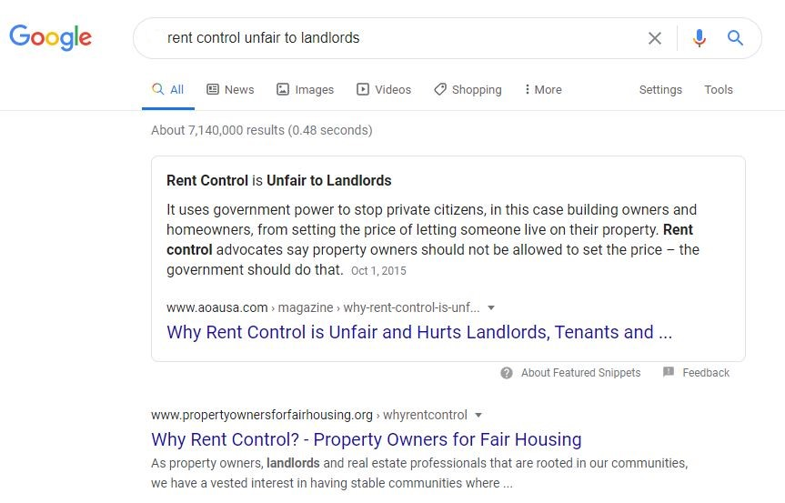
A search for “are immigrants hurting the economy” is likely to get results that argue that immigrants hurt the economy. A better search might be something like “economic effects of immigration”
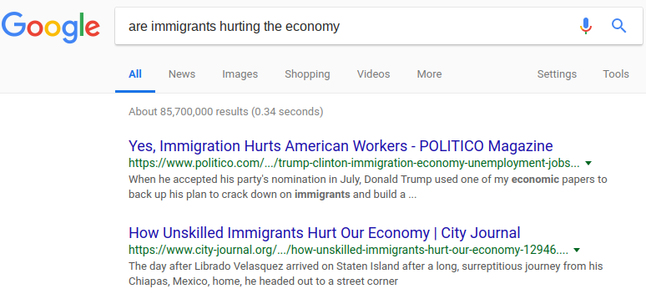

Sources
Casad, Bettina J. “Confirmation Bias.” Encyclopaedia Britannica, 1 Aug. 2016.
Impact on Searching adapted from “Confirmation bias” by Wikipedia, licensed under CC BY-SA 3.0
Page adapted from “Library 10” by Cabrillo College Library, licensed under CC BY 4.0

Chapter 37

Brainstorming Related Terms

Describing Main Concepts
In many instances, there are various ways that a main concept can be described. Not every information source will use the same term to describe the same thing! Take the topic of genetically modified food, for example. Though “genetically modified food” is commonly used, terms like “GMO,” “genetically modified organism,” “genetic engineering,” and “genetic modification” are often used by scientists to describe the same thing.
This is also a good time to look at your main concepts and decide if the keywords you’ve selected to describe them are too broad or too narrow. In the previous example, using the key phrase genetic engineering when looking for information about specific types of organisms that have been genetically modified, may be too broad of a term that yields irrelevant results. Also keep in mind the type of information you are searching for: If you need scholarly research articles, scientific terminology is more likely to be used in those resources; if you are searching for information that may appear in popular periodicals (like magazines and newspapers), more general, everyday language is likely to be used (e.g., myocardial infarction versus heart attack).

Brainstorming Alternatives
It can be helpful to list your keywords and any alternative or related keywords or phrases that may be helpful to your search. You may want to return to those reference sources you used for finding background information on your topic to see what terms and phrases were used. You may also try searching in a thesaurus for some synonyms, and you may even come back to this step later in the research process once you have completed some initial searches and discovered some helpful new alternative terms. Some databases will also list “related terms,” which can be helpful for modifying your search. On the other hand, some keywords are unique, and have no other terms that could be used in their place.
Main Concept/ Keyword | Alternative/Related | Alternative/Related | Alternative/Related
divorce | separation | split up | parental conflict
student’s GPA | grade point average | academic performance | academic achievement
high school | school | secondary school | —

Chapter 38

Creating a Search Statement

Combining Your Keywords
Once you have dissected your research question, found the main concepts, and listed several keywords to describe these concepts (e.g., synonyms, narrower terms, broader terms), it is time to combine those keywords in meaningful ways in order to perform a search for information resources. The combination of terms using various search strategies, called a search statement, will help you get more precise results than typing in a whole research question or just a few words into a search bar. Search statements are almost like a set of instructions given to whatever search option you are using (e.g., library catalog, library database) that describe what you want to find.

Boolean Operators
Named after the mathematician, George Boole, Boolean operators are used as conjunctions that combine or exclude certain keywords in your search. Though Boolean operators are used in logic, mathematics, and computer science, there are three common Boolean operators used by search engines (e.g., library catalogs, academic databases, and some online search engines). Think of Boolean operators as instructions that tell a search engine what to do with your keywords. Some search tools need Boolean operators to be typed in all capital letters in order for them to work, so it is a good idea to always type them in all caps whenever you are using them.
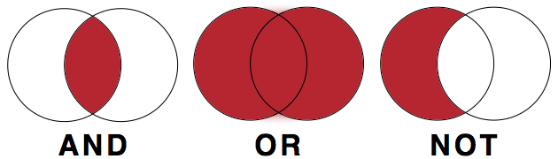

AND
The Boolean operator AND is used between all the keywords and phrases that you want to include in your search. When creating a search statement to find information on the effects of divorce on high school students’ GPA, the Boolean AND operator would go between our three keywords/phrases:
Divorce AND grade point average AND high school
By doing this, the information sources that will be returned in the results will all contain all three of these keywords/phrases somewhere within them.
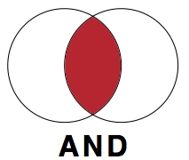

OR
The Boolean operator OR is used to search for alternative keywords. Remember, there are many words that one could use to describe the same concept and OR gives you the option to search for multiple, synonymous terms at once. Instead of searching for various alternative keywords in different searches, OR allows you to search for multiple alternative keywords in the same search.
grade point average OR academic achievement
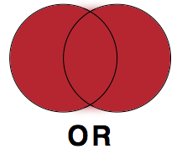

NOT
The Boolean NOT excludes certain keywords from your search. This Boolean operator is not a commonly used one, but can be very helpful if you are getting many irrelevant results. Boolean NOT is best used when using keywords that have associations with multiple things. For instance, if you were trying to search for information on the animal Jaguar and kept getting too many results about the car brand Jaguar, you could use the NOT operator to exclude the word “car” from your search. Jaguar NOT car would exclude any information sources that contained the word car. Be aware that using NOT can exclude relevant results, as well. If an article or website that had some great information on the animal Jaguar, but just so happened to mention the word “car” in the text somewhere, it would be excluded from your results.
Washington NOT George
(when trying to find information on Washington the state, not George Washington)
Mexico NOT city
(when trying to find information on the entire country of Mexico not Mexico City)
Apple NOT fruit
(when trying to find information on Apple the computer company and not apples the fruit)
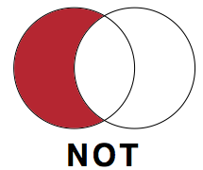

Phrase Searching
Phrase searching allows you to narrow down your search by specifying the exact order you want certain keywords to appear. Quotation marks around two or more keywords (also known as a “phrase”) will keep those words in that exact order during your search. For example, searching for the two keywords computer monitor without the quotation marks may find information sources that have nothing to do with computer monitors, but still contain the two words “computer” and “monitor” (e.g., an article about monitoring computer usage). Searching for “computer monitor” instead locks those keywords together as a unit and will only return results with that phrase “computer monitor.” Unless you are searching for a single keyword on its own, it’s a good idea to use phrase searching to make sure you are getting the most relevant results.
“Grade point average” OR “academic achievement”

Nesting
Just like Boolean, nesting is another concept taken from mathematics that is useful during information searches. When you are using more than one type of Boolean operator in your search statement, nesting—using parentheses around portions of your search statement—will help to organize what Boolean operators go with what keywords. Without nesting, most search engines and library databases will read your search statement from left to right, applying the Boolean operators in that sequence.
Let’s look at two examples:
Divorce AND (“grade point average” OR “academic achievement”) AND “high school”
Divorce AND “grade point average” OR “academic achievement” AND “high school”
In the first example, the search will yield results that contain either key phrase “grade point average” or “academic achievement,” but in the second example without the parentheses, the search will either look for information sources with both the keyword “divorce” and the key phrase “grade point average” or it will find information sources with the key word “high school” and the key phase “academic achievement.” The use of parentheses in this search statement would ensure that the Boolean OR is applied to the two alternative keywords.

Example
Library databases will have the option of either a basic or advanced search. A basic search will require that you type out Boolean operators (in all capital letters) and the parentheses used for nesting. The advanced search will offer you drop-down menus for Boolean operators. If your search statement requires nesting, type the portion of the search statement that would have gone in parenthesis all on one line. See the screenshots below to view the differences between a basic and advanced search.

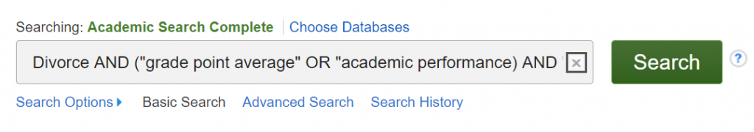

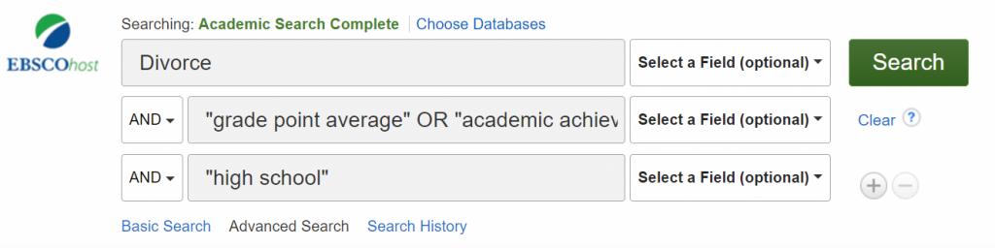

Truncation
There may be times that you want to include all the different word forms of a certain keyword in your search without having to use the Boolean OR and type in each of the different word forms. To use truncation, type in the root word followed by a symbol. In most cases the symbol used for truncating words is the asterisk (*), but this may vary depending on the search engine or library database you are using. For example, searching for child* would return results containing the words child, children, childhood, childish, etc. Watch the following video [3:34] for an explanation of truncation, as well as phrase searching and nesting:
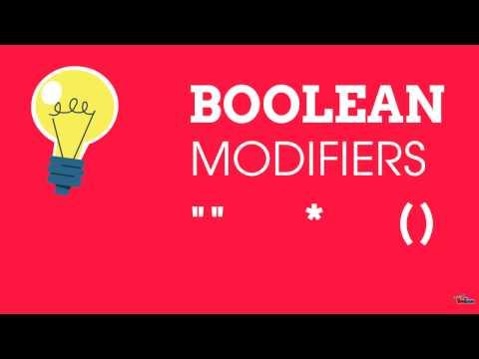
A YouTube element has been excluded from this version of the text. You can view it online here: https://oer.pressbooks.pub/collegeresearch/?p=171
Note: Turn on closed captions with the “CC” button or use the text transcript if you prefer to read.

Sources
“How Library Stuff Works: Boolean Modifiers “”, *, ( )” by McMaster Libraries is licensed under CC BY 4.0
Images from “Search Statements” by Teaching & Learning, Ohio State University Libraries, licensed under CC BY 4.0

Chapter 39

Conclusion
This chapter covered what research questions are, why they are important, and how to create one from your research topic. The research question is the main question you will be trying to answer and will guide your research. You may find that you will change your research question, keywords, and search statement as you go about your research and learn more about your topic.

Sources
Image: “Rainbow Frequency” by Ricardo Gomez Angel is in the Public Domain, CC0

PART VIII

Finding Materials in the Library

Learning Objectives
By the end of this chapter, you will be able to:
- Search for physical materials using your online library catalog
- Describe how libraries organize physical materials on the shelves

Chapter

Chapter Scenario

Scenario
Your US History professor has just assigned you a descriptive essay that is due in two weeks. For this essay, you will need to outline and describe the events that led up to the American Revolution. You are required to use at least two books and one documentary DVD; nothing can be from an online source. You determine that you need to visit the college library to find these resources, but you aren’t sure how to find these resources in the library. You know you can ask for help from the reference librarian, but you want to find the resources yourself. Where do you start?

Chapter

Using OneSearch: Your California Community College Library’s Search Tool

Does your college use OneSearch?
Your California Community College library most likely uses what is known as OneSearch to help you find library resources. If your library does not use OneSearch, there will be a lot of commonalities between your library’s search tool and OneSearch. Speak with your instructor or a college librarian for further clarification.
College libraries hold a wide range of materials: books, DVDs, academic (scholarly) journals, magazines, newspapers, and more. When you use OneSearch, you will not only will find what your library physically owns, but it will also search for materials that the library has access to digitally or online. This can sometimes be confusing and can lead to a lot of search results. Fortunately, OneSearch provides you with ways to limit your search results so that you can identify the specific kinds of resources that you need to find.

Example Search
Let’s consider the scenario presented at the beginning of this chapter. You need to find resources related to the American Revolution—specifically you need to find two books and one documentary film. Let’s look at how you can do this in OneSearch.
If you search for American Revolution, you will see a search result that looks very similar to the one below:

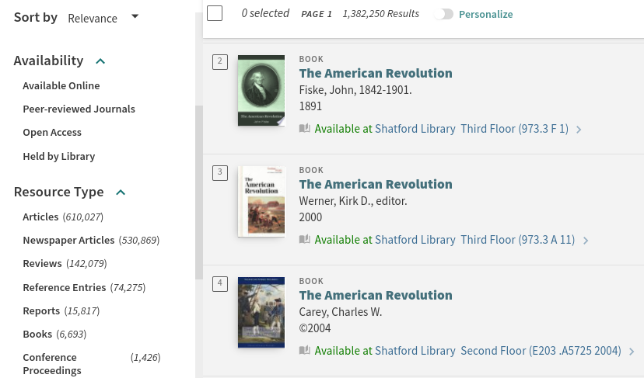

Filtering Results: Availability & Resource Type
In your search results, you should notice some key details. Pay attention to the area to the left of your search results, where you can use filters that control your search results. The first set of filters is labeled as “Availability.” This will indicate how the resources are available. Are they available online? As peer-reviewed journals? You should notice there is an option that says “Held by Library” or something similar to indicate that your library owns those materials. This is a great filter to use to limit your search results that you can access at your library.
Another area to look at is “Resource Type.” Here, you’ll find different formats that you can limit your search results to. For our scenario, what types of resources do you need? We need two books. When you look at the image above, you’ll see that there are 6,693 books that are available in our search results. By clicking on “Books,” you will then be able to browse a list of those items.

Chapter

Critical Thinking

Critical Thinking: Which Book?
In our example search, OneSearch found us 6,693 books, which seems like a great thing because in the scenario, we only need two books. But in reflection, 6,693 books are a lot of books to consider!
How will you determine which two will be the best ones for your research needs? What will you be looking for, and what strategies will you use to assist you to focus your search results?

Chapter

Finding Your Books

Interpreting Your Search Results
After you identify two books that you think you could use, you will need to find those books in the library. Let’s take a closer look at the search results:
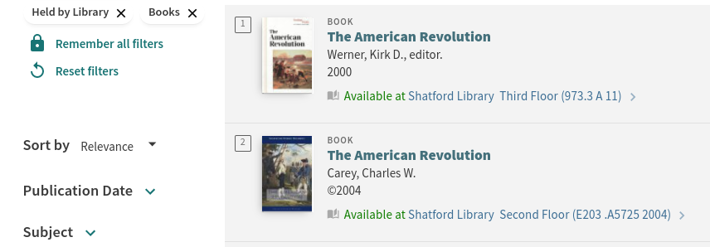
In the above image, we have limited our search results to “Held by Library” and to “Books” as our resource type. These active filters are on the left side of the above image. The top two results in the example are books that are available in the library. We can confirm that these are books by the “Book” label next to the image of the item in the search result. Below the book’s cover, there is another label indicating the book’s availability. Both of these books are labeled as “Available,” meaning they should be in the library. If the book is checked out, missing, or simply unavailable, OneSearch will update the status so that you will know whether or not the book is available for you.

Call Numbers
The first book is called The American Revolution. According to OneSearch, this book is available at this library on its Third Floor.
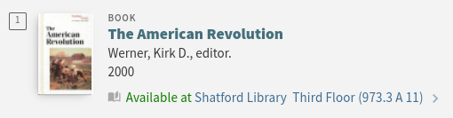
After the location (Third Floor), you should see a set of numbers. These numbers are known as call numbers. Call numbers allow libraries to organize their resources on their shelves in a logical manner; that is, they will be shelved either numerically or alphanumerically (using letters and numbers) according to these call numbers. In the example above, the book’s call number is 973.3 A 11. This means the library has it shelved with other books that are in a 900 range. In the example below, the book’s call number is E203.A5725 2004. This means that this book will be shelved in an area where the call numbers begin with the letter E.
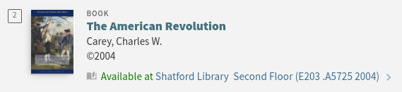
But why do some call numbers begin with letters, while others start with numbers? It all depends on the system your library decides to use to organize their materials. For further explanation, see How Libraries Organize Materials.

Chapter

Filters and Advanced Search Options in OneSearch

Filters
OneSearch provides you with many options to filter your results. We have already discussed “Availability” and “Resource Type.” Other filters that you might see at your library include Publication Date, Subject, Author, and Language.

Advanced Search
You can also click on an option called “Advanced Search” next to the search box at the top of your results (you might have to do a search first to see this depending on how your library has it set up). This option will allow you to be much more specific with your search. For example, let’s say you wanted to find books that have “American Revolution” in the title because you feel that those books will be most relevant to your topic. You also want to find books that address the causes of the American Revolution. This is hard to do in a simple search box. But in the Advanced Search option, you have much more control.
Below is an image of the Advanced Search from OneSearch. You should be able to see that in the first line, the search is set up so that the Title contains “American Revolution.” Then in the second line, there is the option that any field should contain the word “causes.” The search is also limited to a Material Type of “Books.” This Advanced Search has additional menus with other options we could use, such as language and date. You can even add additional keywords by choosing “Add a New Line.”
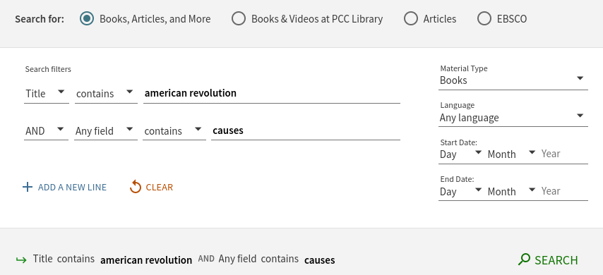

Chapter

Practice

Practice: Finding Other Resources
In the scenario, in addition to finding two books, your history professor also wanted you to find a documentary DVD. How would you find this in the library? What filters might you use? And where do you think it would be located?
TASK: Use your library’s OneSearch to see if you can find one.
If your college library doesn’t have DVDs, are there other options for you through the library? If not, where else could you look?

Chapter

How Libraries Organize Materials

Two Systems
There are two main systems that California community college libraries use to organize materials on the shelves: the Dewey Decimal Classification (DDC) and the Library of Congress Classification (LCC, sometimes also informally called LC or LOC). Both classification systems provide a systematic way for the libraries to keep their materials organized.
Which classification system a library uses depends on local preferences and practices, but in general: academic and research libraries typically use the Library of Congress Classification, while public libraries tend to use the Dewey Decimal Classification. While we will introduce you to both systems, please note that your community college library probably only uses one of these.
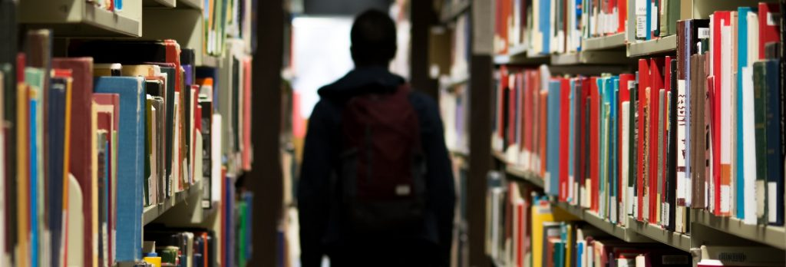

Sources
Image: “Man, Backpack, Books” by bantersnaps is in the Public Domain, CC0

Chapter

Dewey Decimal Classification (DDC)
The Dewey Decimal Classification (DDC) was created by Melvil Dewey in 1873 and is still used by libraries today to organize their collections. The DDC strives to assign all the knowledge in the world to 10 different topical areas organized by number so that each range of numbers (starting with 000–099) is assigned a broad topic area. Below is an outline of these topics.

Dewey Decimal Classification System: Topics
000–099: Computer Science, Information and General Works
100–199: Philosophy and Psychology
200–299: Religion
300–399: Social Sciences
400–499: Languages
500–599: Science
600–699: Technology
700–799: Arts & Recreation
800–899: Literature
900–999: History & Geography
These 10 broad topics are then subdivided into 10 more specific topics. As an example, the 900s–History & Geography is divided below.

900s: History & Geography
900–909: History
910–919: Geography & Travel
920–929: Biography & Genealogy
930–939: History of the Ancient World (to ca. 499)
940–949: History of Europe
950–959: History of Asia
960–969: History of Africa
970–979: History of North America
980–989: History of South America
990–999: History of Other Areas
And then these get broken down even further! Let’s look at the 970s.

970s: History of North America
970: History of North America
971: Canada
972: Mexico, Central America, West Indies
973: United States
974: Northeastern United States
975: Southeastern United States
976: South Central United States
977: North Central United States
978: Western United States
979: Great Basin & Pacific Slope region
When we look at this book that we found with OneSearch, we can see that its Dewey number is in the 900s. That means it is part of History & Geography. Specifically, it is a 973, which means it is about History of North America–United States. The .3 refers to the time period between 1775 – 1789.

Chapter

Critical Thinking

Critical Thinking: The DDC
Reflect on the 970s – History of North America, and the topics that are presented. Do you see anything surprising? If so, what? And what implications do you think this might have for libraries?
970: History of North America
971: Canada
972: Mexico, Central America, West Indies
973: United States
974: Northeastern United States
975: Southeastern United States
976: South Central United States
977: North Central United States
978: Western United States
979: Great Basin & Pacific Slope region

Chapter

Library of Congress Classification (LCC)

How It Works
In contrast to the DDC, the Library of Congress Classification system (LCC) strives to divide all the world’s knowledge into 21 topical areas and groups them alphanumerically. That is, they first assign a topic area to a letter, and then divide that topic up by numbers. Created by the U.S. Library of Congress to meet the needs of its collection, the first outline of the LCC was released in 1904 (“Library of Congress Classification”).

Library of Congress Classification
A: General Works
B: Philosophy, Psychology, Religion
C: Auxiliary Sciences of History
D: World History
E: History of the Americas
F: History of the Americas
G: Geography, Anthropology, Recreation
H: Social Sciences
J: Political Science
K: Law
L: Education
M: Music
N: Fine Arts
P: Language and Literature
Q: Science
R: Medicine
S: Agriculture
T: Technology
U: Military Science
V: Naval Science
Z: Bibliography, Library Science, Information Resources
The LCC then adds numbers after each letter to get more specific within each topic area. Our example from before has the call number E203.A5725. This call number falls within the range E201–298, which is reserved for works about the American Revolution.

How to Find a Book on the Shelf
Please watch this video explanation [1:49], which demonstrates the different elements of LCC call numbers and how they are ordered on a library shelf:
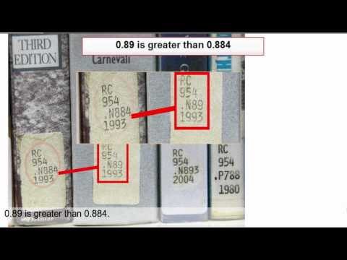
A YouTube element has been excluded from this version of the text. You can view it online here: https://oer.pressbooks.pub/collegeresearch/?p=200
Note: This video has open captions. You may also use the text transcript if you prefer to read.

Sources
“Library of Congress Classification.” Librarianship Studies & Information Technology, 23 June 2020.
“Understanding Call Numbers (Research Minutes).” YouTube, uploaded by Ryerson University Library & Archives, 14 Jan. 2011.

Chapter 40

Practice

Practice: Understanding LCC
You have done a search and found some books about the American Revolution that you now need to find on the shelf.
Their call numbers are:
E203.A5725 2004
E203.A5728 2009
E203.A57 2010
Which book would be first on the shelf and which would be last? Why?

Chapter

Critical Thinking

Critical Thinking: Other Considerations
Libraries use classification systems such as the DDC or LCC to assist with keeping their materials organized on their shelves, but that’s not the only thing that they might use. They might have separate sections to group similar items together. For example, they might have a DVD collection. These may or may not use DDC or LCC, but they will be organized separately from the books. Likewise, there may be a Reserves section, which you may not be able to browse yourself, but you might be able to search for through OneSearch.
What other collections does your library have that might be separated within the library? How will you be able to search for items in those collections? What do you need to know in order to find those items in the library?

Chapter

Conclusion
This chapter outlined how your library organizes materials and provided guidance on how you can search for resources that the library physically owns. Even though there are standards such as the Dewey Decimal System that libraries use to organize their materials, you may find that your college library has some unique and different ways of providing access to their physical collection. So, explore your library shelves and ask a librarian if you’re unsure how to find an item. After familiarizing yourself with the library, it will become much easier to access those resources that you will need to complete your course assignments successfully.

Sources
Image: “Rainbow Frequency” by Ricardo Gomez Angel is in the Public Domain, CC0

PART IX

Using Library Databases

Learning Objectives
By the end of this chapter, you will be able to:
- Differentiate between resources found in library databases and websites
- Identify key differences between resources such as scholarly journals, magazines, and newspapers
- Identify different types of library databases based on resource types
- Use library databases and their embedded tools to support your research assignment

Chapter

Chapter Scenario

Scenario
Your English professor has assigned the class an argumentative essay. Your assigned topic for the essay is artificial intelligence. You are required to find evidence to support your argument from scholarly journals, magazines, newspapers, and books. You have to cite at least seven sources, at least one of each type, and you also have the option to use a video for one of your sources. Your professor states that she doesn’t want you to use websites for your essay; you must use library databases and format your citations according to MLA. You are familiar with searching for books in the library, but unsure how to find the other resources.

Chapter

Library Databases: What’s Inside Them?

Why Library Databases?
Although the internet houses great resources, some websites are not appropriate for college-level research, and sometimes professors have concerns over the information that students might encounter online. In a previous chapter we explored Fact-Checking, and in a later chapter, we will discuss Web Search Strategies to find relevant and reliable resources. Unfortunately, you can’t find everything through a Google search, which is one reason why you’d want to use a library database.
Most library databases provide access to resources that you would normally subscribe to or pay for, such as a newspaper. You can access some newspaper articles for free online, but websites often limit the amount of articles you can view freely. For example, if you visit the Los Angeles Times online you might be able to view one or two articles. After that point, you will need to purchase a subscription to read more. But a library database will provide free access for students and professors at your college.
Another advantage of using a library database is that the resources are secured and safe to access. Some websites require you to accept additional considerations and agreements before accessing materials. But what are you agreeing to? Websites, by their nature, are dynamic resources; their content can change without warning. A resource in a database typically will not change and will often come with a permanent link (sometimes called a “permalink”) so that you can find and share the resource in the future.
Please watch the following video [2:34] for a concise summary of the key differences between using library databases and the Web for your research:
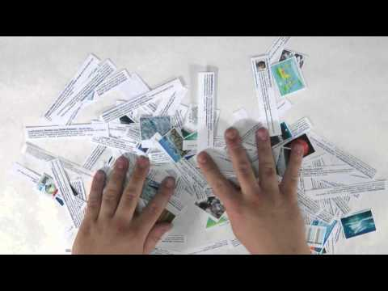
A YouTube element has been excluded from this version of the text. You can view it online here: https://oer.pressbooks.pub/collegeresearch/?p=211
Note: Turn on closed captions with the “CC” button or use the text transcript if you prefer to read.

Additional Database Features
Library databases tend to come with additional tools to support your research. These tools can include help with writing citations, easy-to-use filters to limit your search results, and options to save the article for later use. Whenever you use a library database, you will want to become acquainted with these additional features that will streamline and support your research process.

Takeaways: Library Databases vs. Websites
 | Library Databases | Websites
Cost | Always free for students to access. | Varies. Sometimes you can access resources freely, other times you can’t.
Privacy & Security | Exposure of students’ information is limited through the databases. | You often must “agree to terms” before accessing content on a website.
Reliability | Information in a library database will not change unless the subscription changes. | Websites are dynamic, and content can change daily.
Features | Databases typically come with a range of tools to help you find relevant resources. You have more control over the results you want to see. | Search engines online have limited features to narrow down results. You have less control over the results you want to see.

Sources
“What Are Databases and Why You Need Them.” YouTube, uploaded by Yavapai College Library, 29 Sept. 2011.

Chapter

Critical Thinking

Critical Thinking: Databases or Websites?
Sometimes instructors will say: “Don’t use online sources—use library sources only!”
“But library databases are online,” you say to yourself. But you also understand that your instructor is referring to public websites or sources you can easily find using Google.
So, despite your instructor’s requirements, how would you decide when to use a library database versus a public website? What are a few of the advantages and disadvantages of each?

Chapter

Choosing a Library Database

Many Options
If you look at your library’s database list, you might feel overwhelmed and confused. Why are there so many databases to choose from, and which one should you use? The first thing to realize is that library databases are each unique and specialized. Because of this, libraries tend to subscribe to multiple library databases to provide access to a range of materials that support the curriculum of the college. To choose a database, you need to know what each library database provides access to.

EBSCO, ProQuest, Gale
There are three big companies in the world of library databases: EBSCO, ProQuest, and Gale. Most likely, your library will have access to library databases that are owned by at least one of these, if not all three. Their library databases will generally provide you access to digital versions of resources: ebooks, newspaper articles, magazine articles, and scholarly journal articles. These companies also provide access to multimedia resources, such as streaming video and audio files. Some of the most common library databases from these companies are EBSCO’s Academic Search Complete, ProQuest Central, and Gale’s Academic OneFile. Any of these three library databases will connect you to the full range of resource types.
These three companies (EBSCO, ProQuest, and Gale) own so many library databases that they each also offer an aggregator search tool, which your library might or might not have access to depending on what they subscribe to. An aggregator search tool allows you to search across all of the library databases that your library subscribes to, owned by a single company. So, instead of searching in each of EBSCO’s library databases individually, you can do a single search using EBSCOhost. Likewise, you can use the ProQuest Platform to search across most ProQuest resources, and Gale’s PowerSearch to search across most Gale library databases. These aggregators also allow you to customize which library databases you want to search within. Note, however, that additional features are often available when library databases are searched one at a time.
Beyond these three companies are many others that your library might subscribe to that can be just as or maybe even more resourceful than the databases already discussed. Speaking to one of your librarians to understand which databases are the most appropriate for your research topic is always strongly recommended.

Scenario
Using the scenario for this chapter, and knowing that I need to find resources about artificial intelligence, I might want to focus on library databases that hold science articles (including general, multidisciplinary choices that cover science as well as many subjects). After looking at my library’s database list, I determine that I will start with EBSCOhost and choose EBSCO’s Science Full Text, Academic Search Complete, and MasterFILE. By using EBSCOhost, I’ll be able to search all three of these library databases at the same time.

Chapter

Critical Thinking

Critical Thinking: Choosing a Database
Thinking back to the scenario for this chapter that asks you to find resources about artificial intelligence:
- Which library databases would you use?
- Why would you use those specific library databases?
- Are there any library databases that you would avoid? Why?

Chapter

Specialized Library Databases: Videos, Ebooks, and More!
Your go-to databases for finding scholarly journal articles, newspaper articles, and magazine articles will probably come from EBSCO, ProQuest, and Gale. But what about videos, ebooks, and other special resources? Finding these types of resources will require you to become familiar with specialized databases that your library might subscribe to. Below are charts categorized by resource type listing some of the more popular databases. Your library may subscribe to only a few of these databases or even other databases not listed here, so make sure to always check with a librarian about what resources are available to you.
LIBRARY DATABASES WITH VIDEOS | TYPES OF VIDEOS
Films on Demand | Mostly documentary and instructional
Academic Video Online | Mostly documentary and instructional
Swank | Popular movies
Kanopy | Mostly documentary, with some popular arthouse films
Intelecom | Mostly instructional

LIBRARY DATABASES WITH EBOOKS | TYPES OF EBOOKS
Gale Ebooks | Reference (such as subject-specific encyclopedias and dictionaries) and other non-fiction
EBSCO Ebooks | Non-fiction and fiction
Ebook Central (ProQuest) | Non-fiction and fiction
Salem Ebooks | Reference

SPECIALIZED LIBRARY DATABASES | TYPES OF RESOURCES
Artstor | Images
JSTOR | Scholarly Journals and ebooks
Project Muse | Scholarly Journals and ebooks
Statistical Abstract of the United States | Statistics, Demographics
OverDrive | Audio books, ebooks, magazines
Mango Languages | Language instruction
CQ Researcher | Reports on social issues
Opposing Viewpoints | Articles and resources focused on social issues
SIRS | Articles and resources focused on social issues
Facts on File | Articles and resources focused on social issues

Chapter

Scholarly Articles, Magazine Articles, and Newspaper Articles

Identifying Different Types of Articles
In our scenario, you have to identify and find different types of articles. As pointed out already, the library databases often come with filters that allow you to separate out these different types of resources. There are even some library databases, such as JSTOR, that specialize in scholarly journal articles, or ProQuest’s US Major Dailies, which specializes in newspapers. But what if you’re using an aggregator, such as EBSCOhost, and you aren’t using a filter to limit your search? How will you be able to differentiate a newspaper article from a magazine article or from a scholarly journal article? And why does it matter? There is a separate chapter that goes into the differences between information resources in more depth, but for quick reference consider the following characteristics of these resource types.

Scholarly Articles
Scholarly journal articles are usually long. They are also written with academic language that can sometimes be very technical. Especially in the sciences and social sciences, you will notice predictable sections within them, with subheadings like introduction, literature review, methodology, results/findings, and discussion/conclusion. They’ll have a list of references or works cited, and are often authored by more than one person (especially in the sciences and social sciences). Scholarly journal articles focus on research topics and questions, which means that they may not be reflecting on specific events happening at the moment of publication; rather, they tend to reflect on trends and larger issues.

Magazine Articles
Magazine articles will generally be shorter than scholarly journal articles, written so that they can be understood easily by non-experts, and may or may not have different sections within the article. If they do, the subheadings will not be as predictable as they are in a scholarly journal article from the sciences or social sciences, and the section headings will probably relate back to the topic of the article. A magazine article in PDF format will probably be colorful and have images. You probably won’t find a list of references or works cited at the end of a magazine article. In contrast to scholarly journal articles, magazine articles tend to look at specific events occurring at or around the time of publication, and the authors try to analyze that event to explain why it’s important.

Newspaper Articles
Newspaper articles are usually the shortest of all three article types. Like magazine articles, they are written in simple language to be understood easily by the general public, but because they are shorter, they don’t usually have different subsections within the article. While a printed newspaper article may have some images, there will be fewer than in magazines; newspaper articles in library databases are typically only available as HTML (i.e., no images). They also tend to describe events that are occurring at the moment the article was published, with very little analysis of importance other than the fact that the event happened. First-hand accounts from people who experienced an event are often reported in newspaper articles. Exceptions to this would be editorials and “op-ed” pieces, which are opinion-based articles about an issue.

Sources
Image: “Articles” by Freepik, adapted by Aloha Sargent, from Flaticon.com
Image: “Magazine” by Freepik, adapted by Aloha Sargent, from Flaticon.com
Image: “Newspaper” by Freepik, adapted by Aloha Sargent, from Flaticon.com

Chapter

You Found Some Resources! Now What?

Options

Most library databases give you the option to save, download, or email the resources that you find. You will want to get familiar with how the library databases present these options to you. For example, some library databases allow you to create your own free account within them. The advantage of creating an account (for example, with EBSCO, or ProQuest) is that you may be able to create folders to store links to resources you can easily find again later. You might also be able to save searches, so that you do not have to remember which keywords you entered. You can sometimes set up alerts attached to those searches, so if new resources are added to the library database (which can happen daily), you will be notified about those new relevant resources.

Emailing Sources
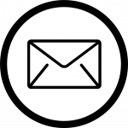
But maybe you do not want to set up an account. Not a problem! Many library databases allow you to send an email to yourself with the article or a link back to the article, without ever creating an account for the company that makes that database (You will, however, have to log in to your college library’s website to access library databases from off campus, so the database knows you are a student there. If you’re unsure how to do this, ask a librarian at your college.) This is where you will need to explore what options the library database offers. Sometimes, the email option is simple; sometimes you will have to fill out a form. If you see a form that needs to be filled out, review it carefully. The library database might be offering some great ways to save you time later, such as an option to include the citation of the article in the email. You can also send the article to other people: If you’re working on a group project and everyone needs to look at the same resources, you might want to include your group members on the email form.

Downloading Sources
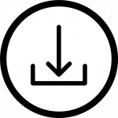
Some people prefer not to email the resource and they just want to download it. This is sometimes an option, depending on the library database and the resource. If it’s available as a download, you might want to keep notes about the resource, so that you remember which library database you found it within, and any publication details you might need to build a proper citation for the resource.

Sources
Image: “Down Arrow” by Becris, adapted by Aloha Sargent, from Flaticon.com
Image: “Mail” by Tomas Knop, adapted by Aloha Sargent, from Flaticon.com
Image: “Settings” by Freepik, adapted by Aloha Sargent, from Flaticon.com

Chapter

Preparing to Use a Database: What Do You Need to Find?
One of the main tasks that you will do within library databases is find articles, often scholarly journal articles. Fortunately, many library databases include filters that limit your results to just scholarly journal articles. This is especially helpful when using the big aggregator search tools from EBSCO, ProQuest, and Gale. But there are often other considerations to take into account when finding resources. As a reminder, always check your assignment requirements and ask yourself these questions:

Assignment Guiding Questions
- How many resources am I required to find?
- What types of resources am I required to find?
- Are there any types of resources that I am not allowed to use?
- Is there a requirement related to the publication date of the resources?
- Are there any other requirements that might be helpful to remember (due dates, citation styles, etc.)?
Let’s look at our scenario for this chapter to answer these questions:

Your English professor has assigned the class an argumentative essay. Your assigned topic for the essay is artificial intelligence. You are required to find evidence to support your argument from scholarly journals, magazines, newspapers, and books.You have to cite at least seven sources, at least one of each type, and you also have the option to use a video for one of your sources. Your professor states that she doesn’t want you to use websites for your essay; you must use library databases and format your citations according to MLA.
According to the Scenario, we can answer the guiding questions as follows:

Answers to Assignment Guiding Questions
- Seven resources.
- At least one scholarly journal article, one magazine article, one newspaper article, and one book. That’s only four out of the seven. You must find more of those resources to equal seven, and you can also use videos. All resources must come from library databases.
- You can’t use websites.
- No publication date restrictions were provided.
- MLA citation style must be used.
Having this information outlined for yourself will help you stay focused as you search through the library databases. After identifying some keywords to seek resources related to your topic, you can then use filters to limit your results to specific resource types (depending on the library database you are using). You should also be able to limit to a publication date when necessary.

Chapter

Full Text? HTML, PDF, and EPUB

Full Text Options
You might also see an option to limit your results to full text. Full text means that you will have full access to the resource. If you want to be able to read the article or view the resource, make sure that the full text option is selected. If you see search results that only bring back a summary, an abstract, or a citation for an article, it’s most likely because you didn’t select the “full text” option in your search filters.
Sometimes, there may be different ways to read the full text of an article or ebook. You might see HTML, PDF, or ePUB presented as options, and each format has strengths and weaknesses. In the end, it’s up to you to decide which one to use. But you will want to be familiar with each type, because sometimes the resource you want to use will only be available in one of them.

HTML
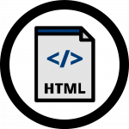
HTML stands for Hypertext Markup Language. This is the basis for all text online. When you see HTML as an option to access the full text of an article or an ebook, it means the article will be presented as text only—much like text on a website, but without any flashy graphics or images. Just the text. What’s great about this is that the text can be manipulated by the library database—manipulated in a good way. It can be converted into other languages, or the library database can read the text aloud or generate a file for you to download an audio version of the resource. HTML full text also tends to load rather quickly, and you can easily copy, highlight, and search through the text using keyboard shortcuts such as CTRL+F or Command+F. There are also disadvantages: Because there are no graphics or images (or when they are available, they are often separate from the text), you can lose context and vital information. Page numbers may be missing, and the text itself may have been loaded with errors from the original source. These can all be very problematic if you will be citing the resource.

PDF
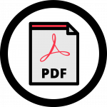
PDF stands for “portable document format” and describes a document that retains or reflects the formatting of a formally published, printed document, with all the images and charts, page numbers, and publication information. In some PDFs, it is possible to select and copy the text, and the text can be recognized by screen readers and other accessibility software. Other PDFs are a scanned image of an original printed document, and the file may not be readable as text by your computer—it might just see an image. This makes it hard to copy and highlight text, and nearly impossible for the computer to translate it into a different language. Depending on the file size and the speed of your internet connection, some PDFs might take longer to load. But you can download them and save the file to read offline later, which is not always possible or easily done with HTML-based resources. Overall, though, PDFs are preferable when doing academic research, and are highly recommended to use because they preserve the look of the original source.

EPUB
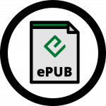
EPUB can be described as a cross between PDF and HTML. This is a file type that you can download and access offline, that will have images embedded within it. But like HTML, the text can be manipulated by the computer or device. EPUBs are adaptable to screen size; text can be reformatted to be easily read on various devices, such as a smartphone or tablet. A PDF doesn’t have that flexibility. The text in EPUBs can be recognized by screen readers and other accessibility software more easily than in PDFs. Disadvantages are that you will find EPUBs almost exclusively with ebooks, and you will need a separate EPUB reader software to read the resource offline; whereas most devices come equipped with PDF readers, not all devices have an EPUB reader installed.

Sources
Image: “ePUB” by Freepik, adapted by Aloha Sargent, from Flaticon.com
Image: “HTML” by Freepik, adapted by Aloha Sargent, from Flaticon.com
Image: “PDF” by Freepik, adapted by Aloha Sargent, from Flaticon.com

Chapter

Critical Thinking

Critical Thinking: What Type of Resource is it?
You come across an article that is available in both PDF and HTML format. You’re unsure if it’s a magazine or scholarly article. What are some key indicators you will look for to assist you in determining which one it is? And then will you download it, email it, or save it for later? Why would you choose one of these ways over the other?

Chapter

Conclusion
In this chapter you were introduced to library databases. Library databases are collections of resources that are selected by your college library to support your academic endeavors. Sometimes the databases specialize in a specific type of resource like streaming videos—other times, they provide you with a wide range of resources such as scholarly journal articles, magazine articles, and newspapers. Library databases can assist you in making your research efforts much more efficient, effective, and organized; and as a student at your college, you will have free access to use your library databases that connect you to content that is not typically free on the Web.

Sources
Image: “Rainbow Frequency” by Ricardo Gomez Angel is in the Public Domain, CC0

PART X

Searching the Web: Strategies and Considerations

Learning Objectives
By the end of this chapter, you will be able to:
- Describe advantages and disadvantages of doing research on the Web
- Identify tools that support online research
- Use search strategies to find resources that are relevant and credible

Chapter

Chapter Scenario

Scenario
Your professor wants you to research antiracism. Specifically, you are to identify efforts and/or policies by government agencies and private organizations that support antiracism. Your professor explicitly states that the library databases cannot be used for this assignment, and you will need to find credible primary and secondary sources online. She wants you to submit an annotated bibliography using MLA style, that includes 10 websites and/or online documents.

Chapter

A Very Brief History of the Internet

Meanings
We use the internet every day. Before we dive into conversations about navigating the rich resources you can find online, it’s helpful to understand what these terms mean and where this all came from.

If a 5-year old child asked you: “What is the internet?” how would you describe it?
This can be challenging, because we may not think about how the internet works, and many of us take the internet for granted. To keep it simple, the internet can be described as a very large network of computers that communicate with each other in standardized ways, so information can be shared efficiently and effectively.

History
In 1969, the first version of the internet was created and set up as a network (called ARPANET) between four “nodes”: UCLA, the Stanford Research Institute, UC Santa Barbara, and the University of Utah (Mack). A student programmer named Charley Kline sent the first message over ARPANET on October 29, 1969. The simple message “LO” was supposed to be “LOGIN”, but the system crashed after the “O” (Norman).
To learn more about these early days of the internet, watch this short video [4:56] featuring Leonard Kleinrock who led the effort:
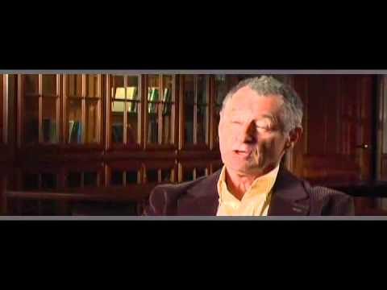
A YouTube element has been excluded from this version of the text. You can view it online here: https://oer.pressbooks.pub/collegeresearch/?p=242
Note: This video is auto-captioned. Accurate captions are available at the Amara version. Use the text transcript if you prefer to read.

What is ARPANET? ARPA stands for Advanced Research Projects Agency. NET is short for network. ARPA was part of the U.S. Department of Defense.
From these humble beginnings came new ways to share information and communicate. In 1971, we had the first email message and saw the creation and international expansion of more networks, which prompted a standard for the networks that was released in 1983 (McDowall). This eventually led to the establishment of the Web, which was released by CERN (the European Council for Nuclear Research) in 1993 and led by Tim Berners-Lee (Greenemeier). Therefore, while the terms are often used interchangeably, the internet is separate from the Web: the Web can be simply described as an application that runs on the internet, facilitating a way to standardize and share information from the internet.
A need emerged for platforms to display information on the Web known as browsers; today, Google Chrome, Mozilla’s Firefox, and Microsoft’s Edge are three popular browsers. A need also emerged for tools that could index and search information within the Web, or search engines; today, these include Google, Yahoo!, and Bing.

Sources
Greenemeier, Larry. “Remembering the Day the World Wide Web was Born.” Scientific American, 12 Mar. 2009.
Mack, Eric. “The Internet Was Born 50 Years Ago with a Nonsense Message.” CNET, 29 Oct. 2019.
McDowall, Mike. “How a Simple ‘Hello’ Became the First Message Sent Via the Internet.” PBS News Hour, 9 Feb. 2015.
Norman, Jeremy. “Charley Kline Sends the First Message Over the ARPANET.” HistoryofInformation, 2020.

Chapter

Critical Thinking

Critical Thinking: Internet Ownership?
The internet is not really owned by anyone, and yet, it is owned by everyone! What do you think that means? If the internet is not really owned by anyone, does that mean everyone has the same access to information across the world? Why or why not?
Do you think there are other issues to consider when thinking about internet management and use? What issues would those be?

Chapter

Search Engines and Tools
As you probably already know, there are many different search engines and tools available for you to use, and many of them are now easily accessible and embedded in the devices we use every day. Long gone are the days when you go to a search engine’s website to begin searching online. As an example, if you need to find the nearest pizza restaurant, you can simply type in your browser’s address bar or ask your phone: “Where’s the nearest pizza restaurant?” and you will be supplied with an answer. Search technology continues to advance as it becomes further integrated into our daily routines.
This can be very convenient, but can also lead to more questions. What search tools are the best to use? Are there disadvantages or risks associated with how search tools are used? Let’s start by discussing the different search tools available.

Chapter

Comparing Search Tools

Common Search Tools & Search Engines
There are many different search tools, and you probably use quite a few without thinking about them, such as artificial intelligence (AI) assistants. Examples include Siri, Alexa, Google Assistant, Cortana, and Bixby. AI assistants are usually voice activated and will search the internet for answers to your questions, suggest resources for you to look at for information related to your question, and perform tasks such as turning on lights or creating a shopping list.
Another type of search tool that you probably use is a search engine. Search engines are online tools that search for web pages based on keywords. Many of these are now embedded in your browsers to make searching online easier, but each have their own websites as well that you can search from. The big names in this area are Google, Yahoo!, and Bing. Though they may bring back different search results, they function overall using the same main principle: to bring back as many relevant results as possible. How each one defines and determines what is “relevant” may differ, and their criteria and methods are typically not transparent to the user.

Other Tools
Besides search engines, there are other online search tools that you might be familiar with but didn’t know what to call them, such as Yelp. There, you can search for businesses and learn information about those businesses, often including links to their websites. Yelp doesn’t search the Web; rather, it maintains its own records and links for those businesses. Because Yelp controls what it searches and what it lists, it is called a directory. Web directories are search tools that link out to hand-selected websites usually organized by categories or topics.
Determining which search tool is the best to use depends on what you are trying to accomplish. If you’re trying to find the nearest pizza restaurant, using an AI assistant is probably really great; using a directory like Yelp might also be helpful. But what about for our scenario? What type of search tool would be the best to use, do you think?

Chapter

Practice

Practice: Comparing Search Engines
Let’s think about the scenario for this chapter and the example assignment. Knowing that search engines rely on your keywords to find relevant results, what keywords would you use?
After you think of a few, test them out!
Try them with an online search engine of your choice and note the top five results. Now try a different search engine. Did you notice any major differences or similarities between the two? Were the results what you were hoping for, or expecting to see? Any surprises?

Chapter

Academic Search Tools

Scholarly Content Online
There are some specialized search tools on the internet that target academic audiences. Perhaps the most popular one is Google Scholar, which looks for academic, scholarly content. Another tool is Microsoft Academic Search. There are also a few subject-specific search tools that you might want to become familiar with, such as PubMed (for the biomedical field) or ERIC (for the education field).

Paywalls
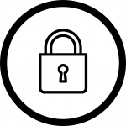
Typically, you would find scholarly content using a library database, but the tools described above can also help connect you to scholarly content that your college subscribes to. The problem—especially for community college students—is that these tools also find a lot of resources that your college might not subscribe to.
For this reason, a lot of the content these search tools will find is behind something called a paywall. A paywall is a barrier you may encounter online, when you have to pay before you can access a resource. Scholarly journal articles you find online come with a price, which can range anywhere from $25 per article up to well over $100 per article!
In our scenario, you have to find 10 resources. That means, for this class assignment, it might cost you anywhere from $250 to over $1000 to complete. At this point, you might be thinking that these academic search tools are not worth using, and we wouldn’t blame you. But these tools don’t always lead you to a paywall, and a paywall is not always a dead end. These tools can help you identify resources that might also be available for free in library databases your college subscribes to, and these tools will often connect you to open access resources.

Sources
Image: “Lock” by Those Icons, adapted by Aloha Sargent, from Flaticon.com

Chapter

Open Access
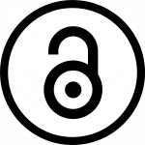
“Open access” refers to resources online—usually academic resources—that are freely available. When trying to find scholarly articles online, you will want to find open access journals or open access articles within more-traditional scholarly journals. Google Scholar and Microsoft Academic Search don’t do a great job of helping you limit your search results to those resources that you have access to, so it can be frustrating at times when using them to conduct research. On the other hand, PubMed and ERIC do provide ways for you to limit your search results to those resources that are freely available. Another resource to check out is The Digital Commons Network, which is a directory of open access articles and resources from universities and publications that you can access freely.
Remember, for any resource that you find online that you cannot access or that has a paywall, consult with a librarian to see if there’s another way for you to access the resource freely. It might be possible for the library to get you access through interlibrary loan, which is when libraries cooperate with each other to provide access to resources that one library may not have, but another library does.

OER: A Special Kind of Open Access Resource
OER stands for Open Educational Resources. OER are materials that can be used and adopted in place of traditional course materials in order to promote equitable access to education as there is no cost for the student or faculty to use OER. That means if your professor uses an OER textbook, you can access that textbook for free online. This is an OER textbook, as an example.
OERs are not limited to textbooks. They could be articles, documents, movies, images, and more. What defines them are the permissions or license that comes with them. Though we won’t dive into all the aspects of licensing and copyright permissions, basically, if the material is licensed so that you can share, revise, and keep a copy of the resource freely, then you have an OER. OER is different than open access in this regard, because open access only allows you to access the resource.

Sources
Image: “Open Access Logo” by PLoS, adapted by Aloha Sargent, is in the Public Domain, CC0

Chapter

Critical Thinking

Critical Thinking: Open Access
Open access as a concept sounds great! These are resources you can access freely online. The internet was created to support sharing information freely. But just because you can access a resource freely doesn’t mean you can do whatever you want with that resource, right? There is copyright to consider. What can’t you do with a resource that you can access freely? It may help to think about YouTube videos. You can access those freely. Can you download them freely? Can you edit them? Should you be able to?

Chapter

Searching and Privacy
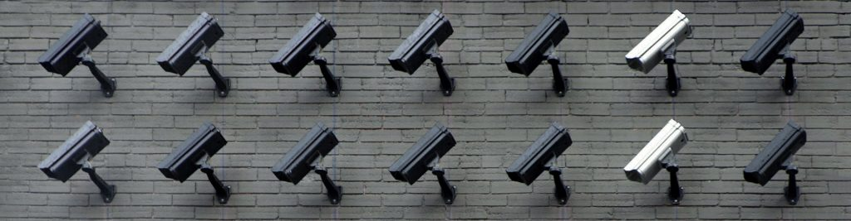

Accept?
Have you ever visited a website and seen a pop-up that says “Accept Cookies” or “Accept Privacy Terms”? These pop-up messages are everywhere! Because we want to see the information on the website, we often click “yes” and move on without giving it another thought. But what information are you giving up? Does it really matter? There are arguments on both sides of the fence here. Some people feel that websites and companies are tracking individuals too much, to the point where targeted ads are infiltrating what people see and experience. Others claim these ads are not as targeted as they seem, and that people aren’t really being tracked—rather, activity is being tracked.

Impact
We do know, however, that your online activity can impact your search results. This phenomenon is called a filter bubble and this occurs most often and strongly within social media, but also within search engines. On social media, you are fed stories based on people or organizations you follow and posts that you liked. This means that, before long, you see only those things that you “liked” or similar items that you have followed. This greatly limits what you see, and a filter bubble is created. Same with search results. Basically, the search tool you use learns about your preferences. It knows your location, for example, therefore, it will provide results relevant to your geography. Search tools can also track the things you click on and will provide similar results in the future. If you start clicking on New York Times articles frequently, you might see more results coming back from the New York Times in your searches. For more on the problematic “personalization” of information we see online, please read the section on Filter Bubbles.

Protecting Privacy
There are steps you can take to combat these behaviors of online tools. One thing you can do is use a search tool that does not track your browsing history. DuckDuckGo is a popular search engine that protects your privacy as you search online. Another step you can take is to use your browser’s “incognito” or “inPrivate” mode. This will also limit what is saved on your computer and prevent or limit tracking behavior as you search.
You should always be vigilant about what you agree to online. Don’t dismiss those pop-ups that you “agree” to so quickly. If you’re on a website that you are unfamiliar with, take the time to read through to what you are agreeing to. You might be surprised, and you will have to decide for yourself if what you agree to is worth what you want to access. Some of these agreements may be harmless; but in the end, it’s your information and your privacy that might be at risk. Only you can determine if and when those values should be waived.

Sources
Image: “Camera Wall” by Lianhao Qu is in the Public Domain, CC0

Chapter

Controlling Your Search
Now that you have learned about tools and some of the issues surrounding searching online, you need to be able to control your search. Just like with library databases, there are strategies you can employ with online searches. Recall that in our chapter scenario, you needed to find information about antiracism efforts of government and private organizations. When forming your search for this scenario, you might use the following keywords: antiracism, government, organizations, policies, and efforts. But you might want to take advantage of some more advanced search commands.

Limiting by Domain
One search command to make note of is site:. This command allows you to search for, or within, specific websites based on domain name. For our scenario, we need government and organizations, so it would be helpful to limit our search to those types of websites. You can set up your search to look something like this:

antiracism policies site:gov
This search example will look for the keywords antiracism and policies within government websites only. The site: command will limit results to those with gov in the website address (also known as the URL). The domain gov is reserved for U.S. government websites.
Other common domains that you could use include .com, .org, and .edu. The domain .org stands for “organization,” however, anyone can use the .org domain, not just non-profit organizations. It is very important to use these domain reservations as guidelines rather than definitive markers of credibility. For example, an .edu website (reserved for educational institutions) could host papers written by students, which might not be appropriate sources for a college-level research paper. Likewise, an .org website could be hosted by a commercial enterprise or even a hate group.

Limiting by File Type
The scenario also asks for online documents. The meaning of this word, “documents,” can be vague and unclear, but its use in the scenario indicates that we’re looking for something you can download, such as a PDF or maybe a Word document. You can also limit your results to file types when searching by using the filetype command. Your search would look something like this:

antiracism policies site:gov filetype:pdf
With the search example above, you will be limiting your search results to government websites that have PDFs related to antiracism policies.

Other Filters
In addition to those commands, there are easy-to-find tools built into search engines. You can search for images, news, maps and more when you search online. You can limit your results to the past year, the past hour, or other time periods. All of these additional limiters can be very powerful and helpful when conducting research, depending on your topic. Explore your search engine to see how much control you can have over your online searching.
- Google Search Help
- Bing Help

Chapter

Practice

Practice: Advanced Search Commands
Think of keywords related to your research, or use the example searches supplied in this section in a search engine of your choice. Try limiting by .edu domain and for documents such as PDFs.
What did you find?

Chapter

Citing: Websites, Web pages, Files, Articles

Considerations
The final part of our chapter scenario asks you to create a bibliography of the websites and online documents that you have found. Citing (including the meaning of “annotated bibliography”) is covered more fully in a later chapter, but for the purposes of this scenario, there are some things to consider:
- Some online academic search tools (such as PubMed) will provide you with citation guidance for resources.
- Websites and web pages are different. Unsure what you are citing? Ask a librarian, or a writing tutor!
- Always check with your professor to confirm what they expect. Some may have customized requirements, and you will need to make sure you create citations that meet those expectations.
- Use online citation generators (such as EasyBib or Citation Machine) cautiously. They can be great timesavers, but they can also create headaches! Make sure you have an authoritative resource to double-check any citation that is created for you, such as Excelsior Owl or your library’s own resources.

Example
Let’s try to cite the following web page together: https://ceo.lacounty.gov/antiracism/
The format for a web page in MLA:
Author’s Last name, First name. “Name of Web Page.” Name of Website, date of publication, website address.
MLA citation for our web page:
“Anti-Racism, Diversity, and Inclusion Initiative.” Chief Executive Office of Los Angeles County, 2020, ceo.lacounty.gov/antiracism/.

Chapter

Conclusion
This chapter provided an overview of considerations and strategies to use when searching online. The Web is full of potentially strong resources, but you have to be able to find them. Knowing how to navigate the Web using search engines and other search tools effectively will assist you in connecting to relevant and reliable resources. Using search strategies and information concepts from other chapters, you will be better equipped to find resources online.

Sources
Image: “Rainbow Frequency” by Ricardo Gomez Angel is in the Public Domain, CC0

PART XI

Ethical and Legal Use of Information

Learning Objectives
By the end of this chapter, you will be able to:
- Describe the value in respecting the original ideas of others
- Define plagiarism and how one can responsibly and ethically use information
- Recognize that students are active participants and creators of scholarship, not just consumers of information

Chapter 41

Contributing to the Conversation
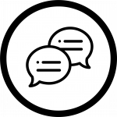
As a college student, whenever you complete an academic assignment, be it a research paper, a speech, or any other assignment in which you gather and synthesize information on a topic, you are participating in what is called a scholarly conversation. The term scholarly conversation describes the existing body of knowledge about a topic. This body of knowledge may include published books, presentations, research articles, conferences, discussions, online resources, and more. Your assignments are a way to add your own voice to the scholarly conversation—by reviewing what research has been done, drawing connections and conclusions from published information, and adding your own experiences, opinions, and ideas about what previous research has shown.

Sources
Image: “Speech Bubble” by Freepik, adapted by Aloha Sargent, from Flaticon.com

Chapter 42

Why We Cite Sources
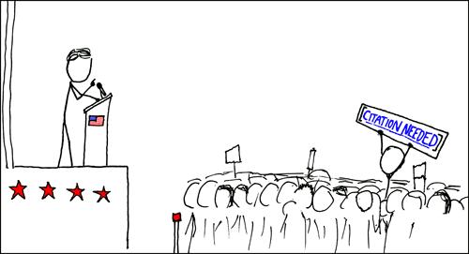

“Academic research leads us to the insight that comes from gaining perspectives and understandings from other people through what we read, watch, and hear. In academic work we must tell our readers who and what led us to our conclusions” (“Ethical Use & Citing Sources”).
When we engage in conversations with other people, we often say things like, “I heard on the news today that…” or “The cashier at the store said…” When we do this, we not only back up and further support the point we are trying to make, but we also give more credibility to what we are saying by letting others know the origin of the information. It is also a good idea to let others know where our information came from when engaging in a scholarly conversation. A citation is a mention to another source and the phrase “citing your sources” means you’ve communicated the sources of information that you’ve used in your own work.
It is unethical to use somebody else’s information in your own work and not cite where you got that information (see section on Plagiarism and Academic Integrity, next). As long as you give credit where credit is due, using information from others to support your own thoughts, opinions, and research findings is good practice. Not only does it acknowledge the hard work of others, but it also shows that you did your research on the topic, you know what information exists about it, and you can integrate your knowledge into the existing research and contribute to the scholarly conversation.
The following video [1:54] by NC State University Libraries has a great summary of what citations are and why we use them:
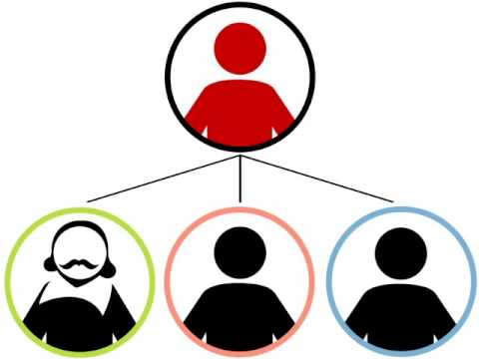
A YouTube element has been excluded from this version of the text. You can view it online here: https://oer.pressbooks.pub/collegeresearch/?p=276
Note: Turn on closed captions with the “CC” button or use the text transcript if you prefer to read.

Sources
“Citation: A (Very) Brief Introduction” by NCSU Libraries is licensed under CC BY-NC-SA 3.0
“Ethical Use and Citing Sources” by Teaching & Learning, Ohio State University Libraries is licensed under CC BY 4.0
Image: “Wikipedian Protester” by xkcd is licensed under CC BY-NC 2.5

Chapter 43

Plagiarism and Academic Integrity

Plagiarism
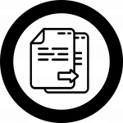
The Merriam-Webster dictionary defines the word plagiarize as “to steal and pass off (the ideas or words of another) as one’s own: use (another’s production) without crediting the source.” When you use the words and ideas of others in your own work without citing where you got that information from, this is considered plagiarism. Whether a student purposely tries to pass off information as their own (i.e., copying and pasting text or paraphrasing another source without giving credit) or does so unintentionally (i.e., not knowing how to cite sources), plagiarism goes against the moral and ethical code for students called academic integrity. Academic integrity is the expectation that all students will be honest and responsible and will not plagiarize or cheat and that they will be motivated by more than just getting good grades. Most colleges have consequences for violating academic integrity, which may include suspension or expulsion from the institution.

“As a student, you will be both using other’s knowledge as well as your own insights to create new scholarship. To do this in a way that meets academic integrity standards, you must acknowledge the part of your work that develops from others’ efforts. You do this by citing the work of others. You plagiarize when you fail to acknowledge the work of others and do not follow appropriate citation guidelines” (“Ethical Use & Citing Sources”).

Intellectual Property

When you avoid plagiarism by citing your sources, you are respecting the time and energy other people put into creating their intellectual property. Just like physical property that you can call your own, intellectual property describes an expression of the human mind that can be owned and protected. Once somebody puts their creative ideas into a fixed and tangible format, like in the form of a book, movie, or song, that becomes intellectual property and can be protected. Intellectual property comes in many forms, but the most popular are copyright, patents, and trademarks. Copyright is the most common form of intellectual property that has relevance for college-level research.

Copyright
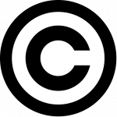
Copyright is a type of protection for intellectual property that is automatically applied to any creative work that is placed in a fixed, tangible format. That means the email that you wrote to your instructor this morning or the doodle you drew in your notes during English are all protected by copyright because they are both in a tangible format and are creative and original (in other words, nothing exactly like them has ever existed until you created them). Though works can be registered through the U.S. Copyright Office, that is not mandatory and even things you see without the copyright symbol (©) or a copyright notice can be (and should be assumed to be) protected by copyright. Copyright gives you exclusive rights to whatever you created, meaning others cannot legally copy, distribute, display, modify, or perform (e.g., a play or piece of music) without getting your permission to do so. Copyright in the United States lasts the life of the creator plus an additional 70 years.

Fair Use

Fair use is an exception to copyright in which you can use a copyright-protected work without getting permission from the creator. There is no hard and fast way to determine whether or not a use of a copyrighted work is a fair use, but there is a four-factor test that can help measure how “fair” the fair use is and whether or not the use is an infringement of copyright. These factors are:
- The purpose and character of your use
- The nature of the copyrighted work
- The amount and substantiality of the portion taken
- The effect of the use upon the potential market.
Fair use weighs heavily in favor of educational uses. So in most cases, using images and/or videos you’ve found online for your presentation for class is not going to land you in hot water. Why is this? Using an image or video that belongs to somebody else without permission for an educational use is not likely to impact the potential market, it is only being shared with the people in your class, and it is being used to educate yourself and others. It is still always good practice to cite where the content came from and try to use openly licensed content that allows people to use it without seeking permission first (see “Creative Commons” section below) whenever possible.

Creative Commons
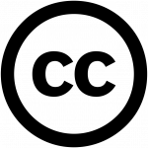
The world’s first copyright law was enacted in the 1700s, way before the invention of the internet. The internet allows people to share information with the touch of a virtual button, yet our current copyright law restricts this type of sharing unless you get permission from the creator first. While copyright means that the picture of your cat that you took and uploaded online cannot be redistributed by anybody else without your permission, it also means that we can’t use copyrighted music in a slideshow of 50 cat pictures you want to put together and share with friends online.
In 2001, a non-profit organization called Creative Commons saw the need for an improvement upon copyright in the digital age. We needed something that enabled the sharing and remixing of knowledge and creativity, which we are able to do so easily online. They developed tools called Creative Commons licenses that allow creators to define what they want others to be able to do and not do with their work. Creative Commons licenses free everyone from needing to track down creators and ask for permission before using their works, and encourage creativity by permitting adaptations and remixes of Creative Commons licensed works.
This textbook incorporates content that is Creative Commons licensed and the entire textbook is licensed with a Creative Commons license, as well, to encourage others to use and adapt the content in a way that works best for them. If you are interested in using images, video, music, and other creative content that has an open license, try CC Search, or try looking for a Creative Commons filter when using Google, Flickr, and YouTube.

Sources
“Ethical Use and Citing Sources” by Teaching & Learning, Ohio State University Libraries is licensed under CC BY 4.0
Fair Use section adapted from “2.4 Exceptions and Limitations to Copyright” by Creative Commons, licensed under CC BY 4.0
Image: “Copyright Symbol” is in the Public Domain
Image: “Creative Commons Logo” is in the Public Domain
Image: “Fair Use Logo” by Óðinn at English Wikipedia is in the Public Domain
Image: “Files” by Smashicons, adapted by Kelsey Smith, from Flaticon.com
Image: “Gears In Bald Head Side View” by Freepik, adapted by Kelsey Smith, from Flaticon.com
“Plagiarize.” Merriam-Webster, 1 Nov. 2020.

Chapter 44

Conclusion
This chapter covered the importance of student voices in the scholarly conversation, or the existing body of knowledge on a certain topic, and how students can support their ideas by referencing past research and published works in a legal and ethical manner. This chapter covered why citing sources is important and the “Citing Sources” chapter will cover how to cite sources.

Sources
Image: “Rainbow Frequency” by Ricardo Gomez Angel is in the Public Domain, CC0

PART XII

Citing Sources

Learning Objectives
By the end of this chapter, you will be able to:
- Give credit to the original ideas of others
- Distinguish between commonly-used citation styles

Chapter 45

Citation Styles

Background
The Ethical and Legal Use of Information chapter covered why you need to cite, and how citations allow you to use other people’s ideas in an ethical way. As the video in that chapter discussed, there are many different citation styles and the one you will use depends on your specific course, instructor, and assignment instructions.

Two Connected Parts
All citation styles include two parts that work together:
- An in-text citation, which is a brief notation (usually within a paragraph, at the end of a sentence) acknowledging that information came from another source. In MLA and APA style, an in-text citation is contained inside parentheses (and sometimes called a “parenthetical citation”). Citation styles that use footnotes or endnotes (such as Chicago or Turabian) may use a superscript in the same way.
- At the end of the paper or assignment, there will be a list of more detailed bibliographic information that enables the reader to find the sources that were used. Every in-text citation must have a matching entry in this list. Depending on what citation style you are using, his list may be called “works cited,” “references,” or “bibliography.” Different citation styles will require you to format these citations in different ways, but they all include similar information, like the author’s name, title of the publication, date, URL, and/or page numbers.
The next section on When to Cite Sources addresses how to incorporate in-text citations and the MLA and APA sections will focus on how to create the full citations for various information source types.

Chapter 46

When to Cite Sources

Overview
As you learned in the chapter on Ethical & Legal Use of Information, it is necessary to give credit to others when you use their information in your assignment. Using other people’s information may come in the form of a direct quote, or summarizing or paraphrasing somebody else’s words. Paraphrasing means you restate what an author said in your own words; summarizing is when you talk about the main concepts or points. When you include someone else’s ideas whether that’s word-for-word (a direct quote), or summarizing or paraphrasing the words of somebody else—you need to include an in-text citation to let others know that the information is not your own, and to allow your reader to go and find the same source you used. Since in-text citations are only brief notations, they will all need a full citation at the end of the assignment or paper. See the each of the MLA and APA chapter for information on creating these full citations.

“Good writers understand why they create citations. The reasons include demonstrating the thoroughness of the writer’s research, giving credit to original sources, and ensuring that readers can find the sources consulted in order to draw their own conclusions about the writer’s argument. Writers achieve the goals of documentation by providing sufficient information in a comprehensible, consistent structure” (MLA Handbook 4).

MLA In-Text Examples:
- Direct Quote: According to Susan Cain, “excessive stimulation seems to impede learning: a recent study found that people learn better after a quiet stroll through the woods than after a noisy walk down a city street” (85). Note: 85 is the page number.
- Paraphrasing: A recent study found that people tend to learn better after they took a quiet walk in the woods as opposed to a noisy walk down a city street (Cain 85). Note: Cain is the author’s last name, and 85 is the page number.
- For a source with no author, cite the title, abbreviated: “The Cooper-Molera garden represents the methods and plantings available in 1860’s California” (“Secret Gardens”). Note: This direct quote comes from a publication called “The Secret Gardens of Old Monterey” that does not mention who the author is.

APA In-Text Examples:
- Direct quote: According to a study on social pain, “acetaminophen reduces behavioral and neural responses associated with the pain of social rejection, demonstrating substantial overlap between social and physical pain.” (DeWall et al., 2010, p. 14) Note: DeWall is the author’s last name, and “et al.” means there are additional authors. 2010 is the year of publication, and 14 is the page number.
- Paraphrasing: In one study by DeWall et al. (2010), it was discovered that over-the-counter painkillers, like Acetaminophen, reduced social pain.
- For a source with no author and/or no date, use the title and n.d. for “no date”: An online poll found that the more time students spent in the library, the higher their overall GPA (“Student Success Poll,” n.d.).

Sources
MLA Handbook. 8th ed., Modern Language Association of America, 2016.

Chapter 47

MLA Style

Overview
The Modern Language Association (MLA) is a professional association for scholars of literature and language. Among other things, the MLA publishes a style manual (sometimes called a “style guide”) for writing and citing sources, used primarily in the humanities, including most English classes. MLA is one of several types of citation styles. As an undergraduate student, some professors or courses may require you to use APA (details below), Chicago, or Turabian style.
It’s not necessary (or advisable) to memorize formatting rules for any citation style. Getting used to checking formatting examples and published guidance (for example, in books or on websites) will help you proofread citations and move more easily between citation styles. There are helpful reference books you can keep on hand (such as the MLA Handbook, which is the style manual mentioned above), and many great online tools through your college library or tutoring websites, or found with a quick online search. Every so often, MLA style (or any citation style), will undergo some changes, and a new edition of the style manual will be released. All citation styles have different formats for citing various information types (e.g., websites, books, podcasts, emails), and as technology advances and information becomes available in new formats, citation styles need to be added and updated.

Works Cited
In MLA style, the list of detailed bibliographic information at the end of the paper or assignment is called “Works Cited.” The core elements of an MLA citation are as follows (be sure to pay attention to the punctuation that follows each element):

MLA Core Elements
- Author.
- Title of source.
- Title of container,
- Other contributors,
- Version,
- Number,
- Publisher,
- Publication date,
- Location.

Author
- A single author should be written: Last name, First name Middle name
- For two authors, only invert the first author’s name. List the names in the order in which they appear on the source.
- For three or more authors, use et al. (which means, ‘and others’).
- When citing an edited book, add a descriptive label (“editor”) after the name. Example: Smith, John M. Example: Smith, John M., and Terence Duvall.

Title of Source
- Include both the title and subtitle separated by a colon [:].
- Capitalize the first word of the title and subtitle, plus all other important words.
- Enclose in “quotation marks:”
  - If the title is part of a larger work, such as a story in an anthology, an article in a journal, or a Web page from a Web site

- Place in italics:
  - If the title is a for an entire book, journal, or Web site

Title of Container
- When a source is part of a larger work, the larger work is called the “container.”
- The container is italicized and followed by a comma.
- Containers can be:
  - Periodicals (magazines, journals, newspapers)
  - Anthologies (books which contain short stories, essays, poetry, etc.)
  - Entire Web sites (which contain individual web pages)
  - Library or other online databases (which contain articles, books, etc.)

Other Contributors
- Contributors other than the author are named in the entry if they are important to your research or the identification of the source (i.e. editors and translators).
- When citing a source with both an author and editor, list the author first and the editor after the title of the source.

Version
If a source carries a notation that it is a work in more than one form (i.e. book edition), identify the version.
- 7th ed.
- Expanded ed.

Number
- Journals are typically numbered with volume (vol.) and issue numbers (no.).
- If you are using a multi-volume set, include the volume (vol.) number.

Publisher
- Only include the first publisher listed, unless the source was published by multiple independent organizations. Separate independent publishers with a forward slash [/].
- Abbreviate publisher names in the following cases:
  - Omit business words like Company, Corporation, Incorporated, and Limited
  - Replace University Press with UP (i.e. Oxford UP, U of California P, MIT P).

- A publisher’s name may be completely omitted for the following types of sources:
  - Web page whose publisher is the same as the name of the overall website
  - Periodical (journal, magazine, newspaper)
  - Work published by the author

Publication Date
- Dates should be given as fully as they appear in your sources.
- If multiple dates are listed, cite the date most meaningful to your use of the source.
- Format as: Day Month Year. Abbreviate the names of months longer than 4 letters

Location
- In print sources, a page number (preceded by p.) or a range of page numbers (preceded by pp.) specifies the location.
- In online sources, location is indicated by the URL, DOI, or Permalink.
  - URL: Copy in full from your Web browser, but omit http:// or https://
  - DOI: Journal articles are often assigned “Digital Object Identifiers”. When possible, cite a DOI (preceded by doi:) instead of the URL.
  - Permalink: Web sources (especially Library databases) often provide stable URLs, called “permalinks”. When possible, use these instead of the URL.

Compiling & Formatting
Once you have constructed your citations according to MLA rules, there are a few more steps to complete the Works Cited list.
- Center the words “Works Cited” at the top of the page.
- Alphabetize the citations by author’s last name, or by the first main word of the title if there is no author. (When alphabetizing, ignore A, An, and The at the beginning of citations.)
- Make sure all lines are double-spaced.
- Apply “hanging” indents to all citations: The first line of the citation is not indented. All subsequent lines are indented 0.5 inch.

Examples
Print Book:
Mancini, Candice. Racism in Harper Lee’s To Kill a Mockingbird. Greenhaven Press, 2008.
Electronic Book:
Schreiber, Brad. Music Is Power : Popular Songs, Social Justice, and the Will to Change. Rutgers UP, 2019. EBSCOhost, search.ebscohost.com/login.aspx?direct=true&db=nlebk&AN=2293722&site=ehost-live&scope=site.
Web page:
Hollmichel, Stephanie. “The Reading Brain: Differences between Digital and Print.” So Many Books, 25 Apr. 2013, somanybooksblog.com/2013/04/25/the-reading-brain-differences-between-digital-and-print/.
Academic Journal Article:
Grauer, Jens, et al. “Strategic Spatiotemporal Vaccine Distribution Increases the Survival Rate in an Infectious Disease like Covid-19.” Scientific Reports, vol. 10, no. 1, Dec. 2020, pp. 1–10. EBSCOhost, doi:10.1038/s41598-020-78447-3.
For more MLA style citation examples, visit Excelsior OWL.

Sources
MLA Handbook. 8th ed., Modern Language Association of America, 2016.
Works Cited section adapted from “Library 10” by Cabrillo College Library, licensed under CC BY 4.0

Chapter 48

APA Style

Overview
The American Psychological Association (APA) is a professional association that represents those working in the field of psychology in the United States. Just like the Modern Language Association (MLA) is often used in the humanities subjects, the APA has their own citation guidelines that are often used to cite sources within the social sciences. Publication Manual of the American Psychological Association is the official reference book, or style guide, for all the details of APA style format, though you can find plenty of helpful guides for free online.

References
In APA style, the list of detailed bibliographic information at the end of the paper or assignment is called “References” and generally, your professors may use the word “references” instead of the word “citations”. The core elements of a APA style citation are as follows (be sure to pay attention to the punctuation used at the end of each element):

APA Core Elements
- Author.
- (Date).
- Title.
- Source.

Author
- List the last name first and the first and middle names as initials.
  - Example: Smith, J. M.

- If there are two authors, use the ampersand (&) instead of the word “and.”
- When there are three to 20 authors, list all of the authors by last name and initials and use an ampersand before listing the last author.
- If there are more than twenty authors, list the first 19 authors then use an ellipsis (…) before listing the last author’s name. Do not use an ampersand before the last author and do not list more than 20 authors’ names total.

Date
- Use a complete date (YYYY, Month DD), if given, otherwise use what is given.
- Use “n.d.” if there is no date given.

Title
- Capitalize only the first letter of the first word of the title and subtitle, the first word after a colon or a dash in the title, and proper nouns (except for journal articles, in which you will capitalize all major words in the title.
- Italicize titles of longer works, like books, collections, websites, or journals. Do not put smaller titles in quotation marks or underline (e.g., chapters, articles, web pages).
- For more details and clarification, read this page on the Excelsior OWL website.

Source
- This is where one can retrieve the cited information, like in a book, on a website, or in a journal article. The format of this section depends on the type of information resource it is. Check out this helpful guide for more information on formatting sources.

Compiling & Formatting
The rules for formatting a list of APA references is similar to MLA format, with some small but important differences:
- Center and bold the word “References” at the top of a separate page
- Alphabetize the citations by author’s last name, or by the first main word of the title if there is no author. (When alphabetizing, ignore A, An, and The at the beginning of citations.).
- If you have multiple citations by the same author(s), list the citations in chronological order, from earliest to most recent.
- Make sure all lines are double-spaced.
- Apply “hanging” indents to all citations: The first line of the citation is not indented. All subsequent lines are indented 0.5 inch.

Examples
Print Book:
Mancini, C. (2008). Racism in Harper Lee’s To kill a mockingbird. Greenhaven Press.
Electronic Book:
Schreiber, B. (2019). Music is power : Popular songs, social Justice, and the will to change. Rutgers University Press.
Web page:
Hollmichel, S. (2013, April 25). The reading brain: Differences between digital and print. So Many Books. https://somanybooksblog.com/2013/04/25/the-reading-brain-differences-between-digital-and-print/
Academic Journal Article:
Grauer, J., Löwen, H., & Liebchen, B. (2020). Strategic spatiotemporal vaccine distribution increases the survival rate in an infectious disease like Covid-19. Scientific Reports, 10(1), 1–10. https://doi-org.whccd.idm.oclc.org/10.1038/s41598-020-78447-3
For more examples of APA style citations, visit Excelsior OWL.

Sources
Publication Manual of the American Psychological Association : The Official Guide to APA Style. 7th ed., American Psychological Association, 2021.

Chapter 49

Citation Steps for Any Style
- Determine the citation style required for your paper or project and refresh your memory on the formatting rules using that citation styles handbook (your college library should have a copy for you to use) or using an online guide, like Excelsior OWL or Citation and Writing Guides from Penn State University Libraries.
- Remember to include your in-text citations as you are writing your paper or pulling your project together. If you don’t include them as you go, it is easy to forget to go back and cite the source, which could lead to accidental plagiarism! See the section on When to Cite Sources at the end of this chapter to learn when you will and will not need to include an in-text citation.
- Identify the information source type you are creating a full bibliographic citation for, since the citation format looks different for different types of information sources. Sometimes, especially online, it can be hard to tell! If you aren’t sure what type of source something is or how to format your citation, ask a librarian or writing tutor.
- Compile your cited sources at the end of your paper or project, being sure to follow the formatting rules of the citation style you are using throughout the assignment. See the section on Citation Generators, next, for information about helpful tools for this task.

Chapter 50

Citation Generators
Unlike 10-15 years ago when college students had to try to memorize citation formats and create each citation by hand, there are now many online tools available that will automatically create citations for many different types of information sources. Citation generators are tools that allow users to type, paste, or import certain information (like a source’s type, title, author, and date), and then create a citation in whatever format is needed (e.g., APA, MLA, Chicago).

Library Databases
Almost all of your college library’s databases will have a convenient citation generator built right into them. In most cases, when you are reading an ebook, academic journal article, or another resource coming from a library database, there will be an icon somewhere on the page for a citation generator. These often offer a list of citation styles to choose from; they provide a citation for that particular source in whatever format is needed, so you can easily copy and paste the full citation into your assignment. The citation generator is not always located in the same spot, and does not always appear the same way in all library databases, but will often say “cite” or have quotation mark icons to indicate that it is a citation tool.
While these citation generators are incredibly helpful and convenient, they do sometimes make mistakes! Always be sure to double-check the citation generated for you—do not assume that all citations generated by a citation tool will be 100% correct.
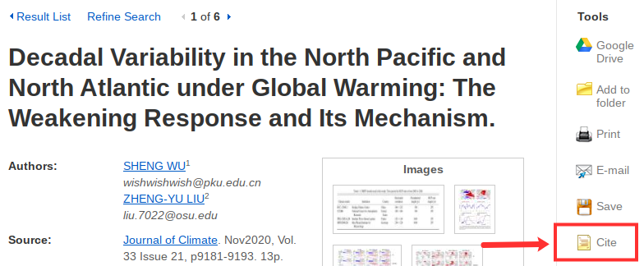

OneSearch
OneSearch also has its own convenient tool located within the record of every item record. The tool is located in the “Send to” section of the record and looks like one set of quotation marks with the word “CITATION” underneath. The citation style can be selected on the left-hand side (but please note, some colleges may list these formats differently from what is shown in the image below). Clicking on “COPY CITATION TO CLIPBOARD” will copy the citation so you can easily paste it into your bibliography (in Microsoft Word, Google Docs, or elsewhere). Besides checking the citation for accuracy, it is also important to check the formatting of your pasted text. Some formatting, like italics, may be lost when copying and pasting. Citation generators are fantastic tools that save a lot of time, but are not always 100% accurate!
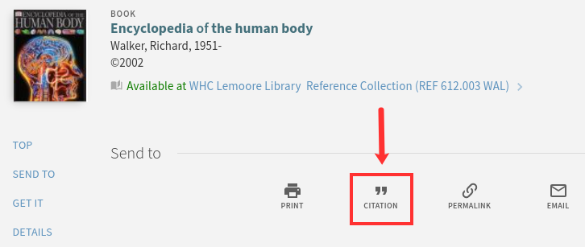

Word Processors
Two commonly used word processors—Microsoft Word and Google Docs—both have citation tools built into the software that make inserting in-text citations and compiling full citations quick and simple.
Microsoft Word’s citation generator is found under the toolbar section called “References,” and the “Insert Citation” tool allows users to plug in bibliographic information about each source used in their paper. The software will keep a running list of the sources, and allows for easy insertion of an in-text citation and a quick combination of citations into a bibliography in the appropriate citation style. An important thing to note is that Microsoft Word may not have the latest citation style format edition; for instance, it may only have the option to create citations in MLA 7th edition, but (as of the time this book was published) MLA 8th edition is the most up-to-date style.
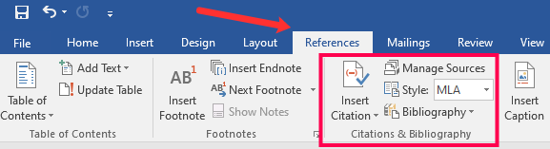
The citation generator in Google Docs is located under the “Tools” menu item on the toolbar. Though this citation tool is much less robust than Microsoft Word’s, only having three citation styles to choose from, it still allows for quick insertion of both in-text citations and a bibliography at the end of the paper. As mentioned previously, the citation styles may not be the latest edition and it is important to always review any citation generated for you.
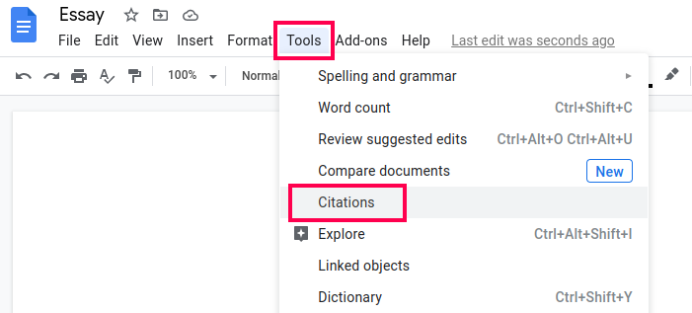

Chapter 51

Conclusion
This chapter covered how to cite information sources in both MLA and APA style format in order to avoid plagiarism. Fortunately, there are many free, online tools, in addition to the style manuals for MLA and APA (and any other citation style) to help you create accurate citations from a variety of different types of information sources.

Sources
Image: “Rainbow Frequency” by Ricardo Gomez Angel is in the Public Domain, CC0

1

Glossary
Academic Integrity

Affective Engagement

Algorithmic Bias

Algorithms

Boolean Operators

Bots

Citation

Confirmation Bias

Copyright

Creative Commons

Cynical

Data Mining

Deepfakes

Dewey Decimal Classification (DDC)

Disinfomation

Doxing

Engagement

Fair Use

Filter Bubbles

Flattening the Curve

Information Competency

Information Cynicism

Information Hygiene

Information Literacy

Intellectual Property

Keywords

Library of Congress Classification (LCC)

Malinformation

Meme

Misinformation

Nesting

Open Access

Paywall

Phrase Searching

Plagiarism

Primary Sources

Related Keywords

Research Questions

Scholarly Conversation

Search Statement

Secondary Sources

SIFT Method

Skeptical

Sock Puppet

Tertiary Sources

Trolling

Vandalism

Wikipedia

